**Subject:** Mercantile Law **Subject Teacher:** Dr D Sanjeeva Rao

**Course:**

**QUESTION BANK**

1. What is the contract? Explain the sources of Indian Contract Act

The Indian Contract Act, 1872 defines the term “Contract” under its section 2 (h) as “An agreement enforceable by law”. In other words, we can say that a contract is anything that is an agreement and enforceable by the law of the land. This definition has two major elements in it viz – “agreement” and “enforceable by law”.

The following are the main sources of Indian Contract Law :

1. English common law : Indian Mercantile law owes its origin to the English Mercantile law. The sources of English mercantile law are common law, equity law, merchant and statute law. The common law of England or the judge-made law (is the unwritten law of England that consists of Judicial decisions and customs), is the preliminary source of Indian Law.
2. Acts enacted by Indian Legislature : The greater part of Indian Business / Mercantile law is legislature-enacted Acts enforced by the Indian Parliament, and these are source of law, which makes it possible to bring uniformity in Indian laws. Changes according to the demand of circumstance can be brought in Indian law effectively by legislative amendments.
3. Judicial decisions or Judicial precedent : Keeping in view the present situation, the verdicts / decisions made by Supreme Court on new issues and emerging debates on them are used as examples by lower courts while taking decisions.
4. Customs and Trade usages : Customs and trades become binding when certain prerequisites are fulfilled. Then the custom is recognised by courts and it becomes legal obligation. In fact, the codified law of India has given superseding powers to the customs and usages.
5. Justice, equity and good conscience : In absence of any rule of a statutory law or custom or personal law on a particular point arising before the courts, the courts apply the doctrine “Justice, equity and good conscience”, which means that in its substance and in circumstances, the rule of English law is applicable to Indian society and circumstances.
6. “All agreements are not contracts but all contracts are agreements. Discuss the statement explaining essential elements of a valid contract.

**“All agreements are not contracts**”

An agreement is a set of promises. Section 2(e) of The Indian Contract Act 1872 says, “Every promise and every set of promises, forming the consideration for each other, is an agreement”. In an agreement, there is a promise between both parties. For example, A promises to deliver his book to B, and in return of B promises to pay Rs. 1,000 to A. there is said to be an agreement between A and B. After acceptance of the offer/proposal it becomes a promise, promise is the result of offer acceptance.

**“All contracts are agreement”**

We know that when an agreement enforceable by law is a contract. A contract is an agreement that is enforceable by law. It is an agreement or set of promises giving rise to obligations that can be enforced or are recognized by law. In order to become an agreement into a contract, it has to satisfy all the essentials of a valid contract as mentioned in section 10 of the Indian Contract Act 1872.

**The essentials of a valid contract:**

1. There must be two parties.
2. The agreement should be between the parties who are competent to contract.
3. There should be a lawful consideration.
4. The object of the agreement must be lawful.
5. There should be free consent between the parties.
6. The agreement must not be one that has been expressly declared to be void.
7. Describe the various classes of contracts. [downloaded pdf]
8. When is an offer said to be complete? Explain the rules of valid offer.

Section 4 of the Indian Contract Act 1872 says that the communication of the offer is complete when it comes to the knowledge of the person it has been made to. So when the offeree (in case of a specific offer) or any member of the public (in case of a general offer) becomes aware of the offer, the communication of the offer is said to be complete.

Essentials of a Valid Offer

A contract is initiated by an offer or proposal. For this purpose, when a contract is formed between two or more parties, the person making the offer is known as the promisor and the person accepting the same is known as an acceptor. An offer so tabled for the acceptance of the recipient must be valid. In this article, we look at the elements of a valid offer in detail.

Express or Implied

An offer can be tabled through words or conduct. An offer made through words (which could be written or spoken), is known as an express contract, whereas the ones addressed through the conduct and actions of the offeror is known as an implied contract.

Legal Relations

An offer is made for the execution of a contract between two or more parties. In this respect, it prompts for the creation of legal relations and legal consequences (in case of non-performance). It is pertinent to note that a social contract without the establishment of legal relations will not constitute a valid offer.

Clarity Matters

An offer must be definite and clear, without which a binding contract isn’t created. A contract of such kind is considered to be void. To state as provided in the respective legal provision, “Agreements, the meaning of which is not certain or capable of being certain are void.”

It is Not an Invitation to Offer

An invitation to offer merely invites the other party for an offer but doesn’t make it. To reiterate, the sender of the invitation intimates the receiver that he/she/it intends to deal with anybody who is willing to negotiate, after duly considering the information furnished in the invite. Communications falling under this category doesn’t constitute an offer.

Specific or General

Offers may be specific or general, and both of these are construed as valid. It may be noted though that if an offer is made to a specific person or for that matter a group of persons, it is termed as specific and can only be accepted by the person to whom it is made. On the other hand, an offer made to the public is termed as general, and such an offer can be accepted by any person who fulfils the specified conditions.

Communication of Offer

An offer stated by the offeror must be clear in its communication so as to facilitate acceptance. Lack of clarity will result in the voidance of the offer made.

Conditional Offer

An offer has scope to be conditional, though an acceptance hasn’t. The person making the offer may include any compliance requirements if deemed necessary. However, an offer shouldn’t have a condition which demands the recipient to accept a one-sided offer. For instance, an offeror cannot state in an offer that a proposal is deemed to be accepted if no response is filed within a given timeline.

No Scope for Cross Offers

Cross-offers take place when two parties make similar offers to each other by ignoring the offer from the other end. The acceptance of cross offers doesn’t make for a complete agreement. This is precisely because if the parties furnish an offer as acceptance of the other, it will potentially lead to issues in the performance of the contract.

5. What are the provisions relating to Acceptance of a Contract?

6. Discuss the law relating to communication of offer, acceptance and revocation.

**Communication of Offer**

Section 4 of the Indian Contract Act 1872 says that the [communication](https://www.toppr.com/guides/business-studies/directing/communication/) of the offer is complete when it comes to the knowledge of the person it has been made to. So when the offeree (in case of a specific offer) or any member of the public (in case of a general offer) becomes aware of the offer, the communication of the offer is said to be complete.

So when two people are talking, face-to-face or via telephone, etc the communication will be complete as soon as the offer is made. Example if A tells B he will fix his roof for five thousand rupees, the communication is complete as soon as the words are spoken.

1. Define consideration. Explain the legal rules as to consideration.

Consideration is a promise, performance, or forbearance bargained by a promisor in exchange for their promise. Consideration is the main element of a contract. Without consideration by both parties, a contract cannot be enforceable. For instance, if a person used the money to purchase an apple, the apple is the merchant’s consideration, and the money is the person’s consideration.

Rules Regarding Consideration

According to Section 2(d) of the Indian Contract Act, 1872, the follows features are essential for a valid consideration:

(i) Consideration must move at the desire of the promisor

Consideration can be offered by the promisee or a third-party only at the request or desire of the promisor. If an action is initiated at the desire of the third-party, it is not a consideration.

(ii) Consideration may move from the promisee to any other person

If you look at the definition of consideration according to section 2 (d) of the Indian Contract Act. 1872, it explicitly states the phrase ‘promisee or any other person…’ This essentially means that in India, consideration may move from the promise to any other person. However, it is important to note that there can be a stranger to consideration but not a stranger to the contract.

(iii) It can be in the past, present or future

1. Past- Since consideration is the price of a promise, it is normally given to induce the promise. However, it can be given before the promise is made by the promisor. This is past consideration.
2. Present - If the promise and consideration take place simultaneously then it is present or executed consideration. An example is Peter goes to a shop, buys a bag of chips and pays for the same on-spot.
3. Future - When the consideration for a promise moves after the contract is formed, it is a future or executor. It is also valid if it depends on the condition.

(iv) It must have value in the eyes of the law - While the law allows the parties to decide an ‘adequate’ consideration for them, it must be real and have value in the eyes of law. While the Court will not consider inadequacy, it will look at it to determine if the consent was given by the party with free-will or not.

(v) It should be over and above the Promisors’ existing obligations - If the promisor is already obligated either by his promise or law to perform or abstain from a certain act, then it is not a good consideration for a promise.

(vi) It cannot be Unlawful - A consideration that is against the law or public policies is not valid.

1. Who is stranger to a contract? What are the exceptions to the Doctrine of privity?

The expression “Privity of Contract” is a doctrine, which means stranger to a contract. It means that a person, who is not a party to the contract, cannot sue for carrying out the promise made by the parties to the contract. That is, a person who is not a party to the contract cannot enforce a contract.

The underlying principle of the doctrine is that a contract is always a privity relationship between the parties who make it. No other person can acquire rights or incur liabilities under it.

Exceptions to Doctrine of Privity of Contract

1. Trust or Charge

Sometimes under contract, a benefit is given to a person who is not a party to the contract. This benefit can be given by creating a Trust or Charge in favour of such person. In such cases, the beneficiary under the trust or charge may enforce the contract even though he is not a party to it.

2. Marriage Settlement, Partition or Other Family Arrangements

Sometimes, an agreement is made in connection with marriage, partition or other family arrangements and a provision is made for the benefit of some person. In such cases, a person, for whose benefit the provision is made, can enforce the agreement though he is not a party to it.

3. Acknowledgement of Payment

Sometimes, one of the parties to a contract acknowledges the payment to a third party or otherwise constitutes himself as an agent of the third party. In such cases, the party incurs a binding obligation towards the third party who can enforce it. And if that party acknowledges the payment to the third person or constitutes himself as an agent of that third person, then the third person can recover the amount from such a party.

4. Agreements Affecting the Land

Sometimes, the owner of land is entitled to certain rights and obligations created by an agreement relating to the land. If such land is purchased by somebody with the notice of rights and obligations of the owner, then those rights and obligations shall bind the purchaser although he was not a party to the agreement.

5. Agency

A principal, even if concealed, may sue on a contract made by an agent. The third party cannot plead that there was no contract between him and the principal.

6. Assignment

The assignee of a debt or an actionable claim may sue the original debtor if the assignment is a legal one.

7. Holder in Due Course

A holder in due course of a negotiable instrument is one who has obtained the negotiable instrument in good faith and for valuable consideration. He can sue prior parties to the negotiable instrument.

8. Fund in Hands of a party

Where a fund is created in the hands of one of the contracting parties in favour of a third party, it may be possible to give the latter, a remedy in quasi-contract on the grounds that to allow the contracting party to keep the fund would be to allow unjust enrichment.

1. A contract without consideration is void – Explain with exceptions.

Consideration

Can you make a legal agreement without consideration? No. As per Section 10 and Section 25 of the Indian Contract Act, 1872, consideration is essential in a valid contract. In simple words, no consideration no contract. Hence, you can enforce a contract only if there is a consideration. While considerations are integral to a contract, the Indian Contract Act, 1872 has listed some exceptions whereby an agreement made without consideration will not be void.

Exceptions to the ‘No Consideration No Contract’ Rule

Section 25 also lists the exceptions under which the rule of no consideration no contract does not hold, as follows:

* Natural Love and Affection

If an agreement is in writing and registered between two parties in close relation (like blood relatives or spouse), based on natural love and affection, then such an agreement is enforceable even without consideration.

### **Past Voluntary Services**

If a person has done a voluntary service in the past and the beneficiary promises to pay at a later date, then the contract is binding provided:

* The service was rendered voluntarily in the past
* It was rendered to the promisor
* The promisor was in existence when the voluntary service was done (especially important when the promisor is an [organization](https://www.toppr.com/guides/business-management-entrepreneurship/organizing/structure-of-organization/))
* The promisor showed his willingness to compensate the voluntary [service](https://www.toppr.com/guides/business-studies/business-services/nature-and-types-of-services/)
* Promise to pay a Time-Barred Debt

If a person makes a promise in writing signed by him or his authorized agent about paying a time-barred debt, then it is valid despite there being no consideration. The promise can be made to pay the debt wholly or in part.

* Creation of an Agency

According to section 185 of the Indian Contract Act, 1872, no consideration is necessary to create an agency.

* Gifts

The rule of no consideration no contract does not apply to gifts. Explanation (1) to Section 25 of the Indian Contract Act, 1872 states that the rule of an agreement without consideration being void does not apply to gifts made by a donor and accepted by a donee.

* Bailment

Section 148 of the Indian Contract Act, 1872, defines bailment as the delivery of goods from one person to another for some purpose. This delivery is made upon a contract that post accomplishment of the purpose, the goods will either be returned or disposed of, according to the directions of the person delivering them. No consideration is required to effect a contract of bailment.

* Charity

If a person undertakes a liability on the promise of another to contribute to charity, then the contract is valid. In this case, the no consideration no contract rule does not apply.

1. Describe the provisions relating to capacity to contract.

Section 11 of the Indian Contract Act, 1872, defines the capacity to contract of a person to be dependent on three aspects; attaining the age of majority, being of sound mind, and not disqualified from entering into a contract by any law that he is subject to.

**1] Attaining the Age of Majority**

According to the Indian Majority Act, 1875, the age of majority in [India](https://www.toppr.com/guides/geography/our-country-india/india-our-country/) is defined as 18 years. For the purpose of entering into a contract, even a day less than this age disqualifies the person from being a party to the contract. Any person, domiciled in India, who has not attained the age of 18 years is termed as a minor.

Let’s look at certain laws governing a minor’s agreement:

**A Contract made with a Minor is Void**

Since any person less than 18 years of age does not have the capacity to contract, any agreement made with a minor is void ab-initio (from the beginning).

*Example, Peter is 17 years and 6 months old. He needs some money to go on vacation with his*[*friends*](https://www.toppr.com/guides/essays/essay-on-friendship/)*. He approached a moneylender and borrows Rs 25,000. As security, he signs some papers mortgaging his laptop and motorcycle. Six months later, when he attains the age of majority, he files a suit declaring that the mortgage executed by him when he was a minor is void and should be cancelled. The Court agrees and relieves Peter of all*[*liability*](https://www.toppr.com/guides/accounting-and-auditing/preparation-of-final-accounts-of-sole-proprietor/classification-of-assets-and-liabilities/)*to repay the*[*loan*](https://www.toppr.com/guides/general-awareness/banks/loans/)*.*

Also, if a minor enters into a contract, then he cannot ratify it even after he attains majority since the contract is void ab-initio. And, a void [agreement](https://www.toppr.com/guides/business-laws-cs/indian-contract-act-1872/agreement-with-minor/) cannot be ratified.

**A Minor can be a Beneficiary of a Contract**

While a minor cannot enter a contract, he can be the beneficiary of one. Section 30 of the [Indian Partnership Act, 1932](https://www.toppr.com/guides/business-laws/the-indian-partnership-act/), also specifies that while a minor cannot become a partner in the [partnership firm](https://www.toppr.com/guides/business-studies/forms-of-business-organisations/partnership/), the benefits of the firm can be extended to him.

*Example, Peter lends some money to his neighbour, John and asks him to mortgage his house as security. John agrees and the mortgage deed is made favouring Peter’s 10-year-old son – Oliver. John fails to repay the loan and Peter, as the natural guardian of Oliver, files a suit against John to recover his money. The Court holds the case since a minor can be a beneficiary of a contract.*

**A Minor is always given the Benefit of being a Minor**

Even if a minor falsely represents himself as a major and takes a loan or enters into a contract, he can plead minority. The rule of estoppel cannot be applied against a minor. He can plea his minority in defence.

**Contract by Guardian**

Under certain circumstances, a guardian of a minor can enter into a valid contract on behalf of the minor. Such a contract, which the guardian enters into, for the benefit of the minor, can also be enforced by the minor.

However, guardians cannot bind a minor by a contract for buying immovable property. But, a contract entered into by a certified guardian of a minor, appointed by the Court, with approval from the Court for the sale of a minor’s property can be enforced.

**Insolvency**

A minor cannot be declared insolvent as he cannot avail [debts](https://www.toppr.com/guides/economics/government-budget-and-the-economy/debt/). Also, if some dues are pending from the properties of the minor and he is not personally liable for the same.

**Joint contract by a Minor and an Adult**

In case of a joint contract between an adult and a minor, executed by the guardian on behalf of the minor, the [liability](https://www.toppr.com/guides/accounting-and-auditing/preparation-of-final-accounts-of-sole-proprietor/classification-of-assets-and-liabilities/) of the contract falls on the adult.

**2] Person of Sound Mind**

According to Section 12 of the Indian Contract Act, 1872, for the purpose of entering into a contract, a person is said to be of sound mind if he is capable of understanding the contract and being able to assess its effects upon his interests.

It is important to note that a person who is usually of an unsound mind, but occasionally of a sound mind, can enter a contract when he is of sound mind. No person can enter a contract when he is of unsound mind, even if he is so temporarily. A contract made by a person of an unsound mind is void.

**3] Disqualified Persons**

Apart from minors and people with unsound minds, there are other people who cannot enter into a contract. i.e. do not have the capacity to contract. The reasons for disqualification can include, political status, legal status, etc. Some such persons are foreign sovereigns and ambassadors, alien enemy, convicts, insolvents, etc.

11. Explain provisions relating to minor’s agreements.

**RULES REGARDING MINOR’S AGREEMENT**

A minor’s agreement being void is wholly devoid of all effects. When there is no contract there should be no contractual obligation on either side.

1. **An agreement with or by minor is void**  
            Section 10 of the Indian Contract Act requires that the parties to a contract must be competent and Section 11 says that a minor is not a competent. BUt either section makes it clear whether the contract entered into by a minor is void or voidable. Till 1903, court in india wee not unanimous on this point the privy council made it perfectly clear that a minor is not competent to a contract and that a contract by minor is void *ab initio.*  
The leading case is:

**MOHRI BIBI V. DHARMO DAS GHOSE (1903)**

    “A minor borrowed Rs. 20000 from B and as a security for the same executed a mortgage in his favor. *He became*   *a major a few months later and filled a suit for the declaration that the mortgage executed by him during his majority was void and should be cancelled. It was held that a mortgage by a minor was void and B was not entitled to replacement of money.*

2*.***No ratification**

            An agreement with the minor is completely void. A minor cannot ratify the agreement even on attaining majority, because a void agreement cannot be ratified. A person who is not competent authorize an act cannot give it validity by ratifying.

   But If on becoming major, minor makes a new a new promise for fresh consideration, then this new promise will be binding.

3. **Minor can be a promise or beneficiary**

            If a contract is beneficiary to a minor it can be enforced by him. Their is no restriction on a minor from bring a beneficiary, for example, being a payee or a promisee in a contract. Thus a minor is capable of purchasing immovable property and he may sue to recover the possession of the property upon tender of the purchase money. Similarly a minor in whose favor a promissory note has been executed can enforce it.

4. **No estoppel against a minor**

            Where a minor by misrepresenting his age has induced the other party enter into a contract with him, he cannot be made liable on the contract. There can be no estoppel against a minor. It means he is not estoppel from pleading his infancy in order to avoid a contract.

5. **No Specific performance Except in certain cases**

            A minor’s contract being absolutely void, there can be no question of the specific performance of such contract. A guardian of a minor cannot bind the minor by an agreement for the purchase of immovable property ; so the minor cannot ask for the specific performance of the contract which the guardian had no power to enter into.

But a contract entered into by guardian or manager on minor’s behalf can be specifically enforced if

(a) The contract is within the authority of the guardian or manager.

(b) It is for the benefit of the minor.

(**LALCHAND V. NARHAR 89 IC 896**)

6. **Liability for torts**

            A trot is a civil wrong. A minor is liable in tort unless the tort in reality is a breach of contract. Thus, where a minor borrowed a horse for riding only he was held liable when the he lent the horse to one of his friends who jumped and killed the horse.

   But a minor cannot be made liable for a breach of contract by framing the action on tort. you cannot convert a contract into a tort to enable you to sue an infant.

7. **No insolvency**

            A minor cannot be declared insolvent as he is incapable of contracting debts and dues are payable from the personal properties of minor and he is not personally liable.

8. **Partnership**

            A minor being incompetent to contract cannot be a partner in a partnership firm, but under Section 30 of the Indian Contract Act , he can be admitted to the benefits of partnership.

9. **Minor can be an agent**

            A minor can act as an agent. But he will not to be liable to his principal for his acts. A minor can draw, deliver and endorse negotiable instruments without himself being liable.

 10. **Minor cannot bind parent or guardian**

            In the absence of authority, express or implied, an infant is not capable of binding his parent or guardian, even for necessaries. The parents will be held liable only when the child is acting as an agent for parents.

 11. **Joint contract by minor and adult**

            In such a case, the adult will be liable on the contract and not the minor. In **Sain Das Vs Ram Chand,** where there was a joint purchase by two purchaser, one of them was a minor. It was held that the vendor could enforce the contract against the major purchaser and not the minor.

 12. **Surety for a minor**

            In a contract of guarantee when an adult stands for a minor then he (adult)is liable to third party as there is direct contract between the surety and the third party.

 13. **Minor as Shareholder**

            A minor, being incompetent to contract cannot be a shareholder of the company. If by mistake he become a member, the company can rescind the transaction and remove his name from register. But, a minor may, acting through his lawful guardian become a shareholder by transfer or transmission of fully paid shares to him.

 14. **Liability for necessaries**

            The case of necessaries supplied to a minor or to any other person whom such minor is legally bound to support is governed by section 68 of the Indian Contract Act. A claim for necessaries supplied to a minor is enforceable by law. But a minor not liable for any price that he may promise and never for more than the value of the necessaries. There is no personal liability of the minor, but only his property is liable.

12. When is consent not said to be free?

Free Consent is a vital part of a sound contract. But how does the law determine if two parties have willingly and knowingly entered into a contract? For a contract to be enforceable consensus ad idem i.e meeting of minds of all the parties involved is necessary.

According to Section 13 of the Indian Contract Act, 1872  two or more persons are said to be in consent when they agree on the same thing in the same sense (Consensus-ad-idem). This means that the two parties must have the same understanding with regards to the subject matter of the contract. If consent is gained by coercion or even mistake the contract will not be considered enforceable by law.

**For Example-** Ankita agrees to sell her house to Ira. Ankita owns three houses and wants to sell the house in Delhi. Ira thinks she is buying her Mumbai House. Here there is no Consensus-ad-idem between Ankita and Ira. Hence there is no consent and therefore no contract between them.

**Case Law-**

**In Raffles vs Wichelhaus(1864)**, two parties part A and part B entered into a contract for sale for 125 bales of cotton arriving from Bombay by a ship named “Peerless”.There were two ships with the same name and while party A had one ship in mind, Party B had the other ship in mind.**It was held by the court that both the parties were not *ad idem*and therefore the contract was void.**

According to section 14 of the Indian Contract Act, 1872, consent is said to be free when it is not caused by-

1)**Coercion**– as defined in section 15

2)**Undue Influence** -as defined in section 16

3)**Fraud** – as defined in section 17

4)**Misrepresentation-** as defined in section 18;or

5)**Mistake**– subject to the provisions of section 20,21,22

If consent is given under any of the above four circumstances, the contract is considered voidable and shall be considered enforceable only at the option of the aggrieved party(section 19 of Indian contract act,1872).

If the consent is caused by a mistake of fact of both the parties, the contract shall be considered void.

## 1)Coercion

According to section 15 of the Indian Contracts Act,1872 coercion is –

1. Committing or threatening to commit any act forbidden by the Indian Penal code.
2. The Unlawful threatening or unlawful detaining of any property to the prejudice of any person.

-With the intention of causing the other person to enter into an agreement.

It is, however, immaterial whether the Indian Penal Code is or is not in force in the place where the coercion takes place.

## The threat to commit suicide

**Chikkam Ammiraju and Ors. v. Chikkam Seshamma and Anr(1917)**

In this case, a husband threatened his wife and son to commit suicide if they did not release a sale added in favor of his younger brother. They executed the deal but later filed a plea of coercion. Since the very act of committing suicide is forbidden under the Indian Penal Code,1860.

**Held that threat to commit suicide also amounts to coercion and the party who is affected by it has the right to avoid the contract.**

## 2)Undue Influence

When the relations between two parties areas such that one of the party is in a position to dominate the will of the other party and use that position to gain an unfair advantage over the other it amounts to undue influence under section 16 of the Indian Contracts Act,1872.

Therefore any influence with the help of which free and deliberate judgment is excluded is called undue influence.

According to section 16(2), a person is said to have a dominant position when-

1)He is involved in a relationship involving trust and has real authority.

2)He is involved in a contract with a person whose mental capacity is permanently or temporarily affected due to age, illness or mental or bodily distress.

**Lingo Bhimrao Naik v. Dattatrya Shripad Jamadagni**

In this case, the mother of an adopted son was alleged to have used undue influence on her son in order to gain consent when he reached the age of majority to ratify the gift deeds made to her daughters with regards to non watan property and did not let him consult his natural father.

**Held -The adoptive mother used her position of authority to dominate her son into ratifying the gift deeds nor was the son aware of his legal rights, therefore, the court set aside the matter.**

## 3)Fraud

Consent is not considered to be free when it has been gained by fraud. Fraud is a false representation of facts with the intention to deceive the other party. Fraud is proved when false representation has been made-

1.Knowingly

2.Without belief in its truth

1. Recklessly whether it is true or not

So according to Section 17, a fraud is when one party convinces another party to enter into an agreement by-

1.Suggesting a fact that is not true or which he does not believe it to be true(Suggestio falsi)

2.Active concealment of facts while having knowledge of the fact(Suppresio veri)

3.Making a promise made without any intention of performing it.

4. Performing any other such act with the intention to deceive.

5.When the act is considered fraudulent by the court.

**Section 17(1)**says that to constitute fraud, there should be a statement of fact which is not true. The mere expression of opinion shall not constitute a fraud.

### Mere silence not fraud

Section 17 clearly states that mere silence does not constitute fraud. But Active concealment of facts requires efforts to conceal the truth therefore when silence amounts to active concealment of facts, it amounts to fraud.

**In Bimla Bai vs Shankarlal (AIR 1959)**, A father called his illegitimate son, “Son” at the time of fixing his marriage. It was held that the father knowingly concealed the illegitimacy of the son with the intention of deceiving the Brides parents which amounted to fraud.

#### Exceptions

1)When there is a duty to speak, keeping silence is fraud.

2)When silence is in itself equivalent to speech, silence is considered fraud.

**In KIRAN BALA vs. BHAIRE PRASAD SRIVASTAVA(1982),** the first marriage of the appellant was annulled on the grounds that she was not of sound mind at the time of marriage. She was married for the second time to the respondent keeping the reason for the annulment of the first marriage a secret from the groom and his parents. I**t was held by the court that the consent of the groom has been attained through fraud and it annulled by a decree under the Hindu marriage act.**

## 4)Misrepresentation

Misrepresentation is defined under section 18 of the Indian Contracts Act and can be divided into 3 types-

1)First is when the statement is made about a fact which is not true, though he believes it to be true.

2)Second is the type when there is a breach of duty by a person who is making the false statement and he gains some kind of advantage even though it wasn’t his intention to deceive the other party.

3)The third type is when one party acts innocently and causes the other party to make any mistake with regards to the subject matter of the agreement.

The common point between the three types is that the misrepresentation is an innocent mistake made without the intention to deceive the party.

The burden of proof lies on the party whose consent has been gained through misrepresentation and is voidable at the option of the aggrieved party although he cannot sue the other party for damages.

## 5)Mistake

A mistake under Indian Contract Law is considered to be of two types-

1)Mistake of Fact

2)Mistake of law

## Mistake of fact

When there is a misunderstanding of fact by both or one of the parties, it is considered to be a mistake of fact. The mistake of fact can be of 2 types-

### 1)Bilateral Mistake

Section 20 says that when both the parties do not agree on the same thing in the same sense and therefore are under a mistake of fact which is essential to the contract, they are said to have committed a Bilateral mistake. This contract is said to be void.

### 2)Unilateral Mistake

Section 22 says that if one person has made a mistake of fact, the contract will not be void or voidable and will remain a valid contract unless the mistake of fact is regarding the subject matter of the contract or the identity of the person contracted with.

**In Dularia Devi v. Janardan Singh(1990)**,

## Mistake of Law

Section 21 of the Indian Contract Act,1872 is based on the maxim- Ignorantia Juris non-exusant which means ignorance of the law is no excuse. Hence it provides that a contract is not voidable because it was caused by a mistake as to any law in force in India.

### Exceptions

1)Private Rights of Property-aA party cannot fully know the private rights of the other party, therefore it is excusable.

2)Mistake as to any foreign law is considered to be treated like a mistake of fact and is considered excusable since knowledge of foreign laws is not necessary.

13. When is the consideration or object said to be unlawful?

Section 23 of the Indian Contract Act clearly states that the [consideration](https://www.toppr.com/guides/business-laws/indian-contract-act-1872-part-i/legal-rules-regarding-consideration/) and/or object of a contract are considered lawful consideration and/or object unless they are

* specifically forbidden by law
* of such a nature that they would defeat the purpose of the law
* are fraudulent
* involve injury to any other person or property
* the courts regard them as immoral
* are opposed to public [policy](https://www.toppr.com/guides/commercial-knowledge/government-policies-for-business-growth/policy-decisions-and-goals/).

### ****1] Forbidden by Law****

When the object of a contract or the consideration of a contract is prohibited by law, then they are not lawful consideration or object anymore. They then become unlawful in nature. And so such a contract cannot be valid anymore.

Unlawful consideration of object includes acts that are specifically punishable by the law. This also includes those that the appropriate authorities prohibit via rules and regulations. But if the rules made by such authorities are not in tandem with the law than these will not apply.

### ****2] Consideration or Object Defeats the Provision of the Law****

This means if the contract is trying to defeat the intention of the law. If the courts find that the real intention of the parties to the agreement is to defeat the [provisions](https://www.toppr.com/guides/accountancy/depreciation-provision-and-reserves/provisions/) of the law, it will put aside the said contract. Say for example  A and B enter into an agreement, where A is the debtor, that B will not plead limitation. This, however, is done to defeat the intention of the Limitation Act, and so the courts can rule the contract as void due to unlawful object.

### ****3] Fraudulent Consideration or Object****

Lawful consideration or object can never be fraudulent. Agreements entered into containing unlawful fraudulent consideration or object are void by nature. Say for example A decides to sell goods to B and smuggle them outside the country. This is a fraudulent transaction as so it is void. Now B cannot recover the money under the law if A does not deliver on his promise.

### ****4] Defeats any Rules in Effect****

If the consideration or the object is against any rules in effect in the country for the time being, then they will not be lawful consideration or objects. And so the contract thus formed will not be valid.

### ****5] When they involve Injury to another Person or Property****

In legal terms, an injury means to a criminal and harmful wrong done to another person. So if the object or the consideration of the contract does harm to another person or property, this will amount to unlawful consideration. Say for example a contract to publish a book that is a violation of another person’s copyright would be void. This is because the consideration here is unlawful and injures another person’s property, i.e. his copyright.

### ****6] When Consideration is Immoral****

If the object or the consideration are regarded by the court as immoral, then such object and consideration are immoral. Say for example A lent money to B to obtain a divorce from her husband C. It was agreed once B obtains the divorce A would marry her. But the court passed the [judgement](https://www.toppr.com/guides/reasoning-ability/statements/judgements/) that A cannot recover money from B since the contract is void on [account](https://www.toppr.com/guides/fundamentals-of-accounting/accounting-process/types-of-accounts/) of unlawful consideration.

### ****7] Consideration is Opposed to Public Policy****

For the good of the community, we restrict certain contracts in the name of [public policy](https://www.toppr.com/guides/commercial-knowledge/government-policies-for-business-growth/public-policy-and-its-features/). But we do not use public policy in a wide sense in this matter. If that was the case it would curtail individual freedom of people to enter into contracts. So for the purpose of lawful consideration and object public policy is used in a limited scope. We only focus on public policy under the law.

14. What are agreements opposed to public policy?

## **Trading With Enemy**

When there is a war between two countries, it is unlawful and against public policy that a person should trade with the subject of the enemy country. A person from one country cannot trade with the people of other country which is in war with the first country.

## **Trafficking In Public Offices**

An agreement by which it is intended to induce a public officer to act corruptly is termed as a contract which is against public policy. For example, in Parkinson v. College of Ambulance an agreement by which a sum of money was provided to a charity for the procurement of knight in return was deemed to be a void agreement. The aforesaid case is a precedent in English case law.

## **Interference With Administration Of Justice**

A contract whose object is interfere with the administration of justice is void in the eyes of law as it is opposed to the public policy. With reference to such administration this heading can be categorised further as:  
  
**Interference with the course of justice**  
Any agreement which obstructs the ordinary process of justice is void. An agreement to delay z money to induce a person false evidence, have been held void.

**Stifling prosecution**  
An agreement to stifle prosecution has been regarded as opposed to public policy. Under criminal law it is been termed as no compoundable offence. In other words, by accepting some consideration to make a compromise in a criminal case, one is deemed to have accepted bribe, i.e., a crime under I. P. C.A case is been discussed so as to explain this category as per Indian law

**Agreements of maintenance and champerty**  
Maintenance as per law is, aiding a party in civil proceeding by providing financial or other assistance without lawful justification. In other words, of a person intermediates in the proceedings of a case of any two parties without having any interest is termed to be an unlawful interference by the third party.

## **Marriage Brokerage Contract**

Marriage brokerage contracts mean such contracts under which a person agrees to procure a marriage between two persons on some consideration. Such agreements are opposed to public policy and are void. As per Indian laws marriages are those scarce ceremonies which should be commenced by both the parties independently agreeing to form such relation rather than by involving intermediaries who try to procure such marriages for their own selfish motives. The common law governing the English law forms precedent for the Indian law as well under this rule. A popular in English law forms precedent in Indian law. The case is **Hermann v. Charlesworth**, in this case Charlesworth promised to introduce young men to Miss Hermann and in return she was to pay 52 pounds in advance and 250 pounds on the day of marriage. He was unsuccessful to procure the marriage, so Miss Hermann who had paid the advance, brought an action against Charlesworth to recover back the money which she paid in advance, and she was successful.

## **Unfair Or Unreasonable Dealings**

When the parties are not economically on equal footing with respect to the bargaining power of the two parties and one party is in a position to exploitthe other party and the other party is vulnerable in such respect then the agreement is termed to be as opposed to the public policy and may be termed to be void in the eyes of law. In the case of  
**Central Inland Water Transport Corps v. Brojo Nath Ganguly**

15. What are the provisions relating to contingent contracts?

Under Section 31 of the [Indian Contract Act, 1872](https://www.toppr.com/guides/business-laws/indian-contract-act-1872-part-i/), contingent contracts are defined as follows: “If two or more parties enter into a contract to do or not do something, if an event which is collateral to the contract does or does not happen, then it is a contingent contract.”

### Essentials of Contingent Contracts

#### 1] Depends on happening or non-happening of a certain event

The contract is contingent on the happening or the non-happening of a certain [event](https://www.toppr.com/guides/maths/probability/event-and-its-types/). These said events can be precedent or subsequent, this will not matter. Say for example Peter promises to pay John Rs 5,000 if the Rajdhani Express reaches Delhi on time. This is a contingent event.

#### 2] The event is collateral to the contract

It is important that the event is not a part of the contract. It cannot be the performance promised or a [consideration](https://www.toppr.com/guides/business-laws/indian-contract-act-1872-part-i/legal-rules-regarding-consideration/) for a promise.

Peter enters into a contract with John and promises to deliver 5 television sets to him. John promises to pay him Rs 75,000 upon delivery. This is NOT a contingent contract since John’s obligation depends on the event which is a part of the contract (delivery of TV sets) and not a collateral event.

Peter enters into a contract with John and promises to deliver 5 television sets to him if Brazil wins the FIFA World Cup provided John pays him Rs 25,000 before the World Cup kicks-off. This is a contingent contract since Peter’s obligation arises only when Brazil wins the Cup which is a collateral event.

#### 3] The event should not be a mere will of the promisor

The event cannot be a wish of the promisor. Say for example Peter promises to pay John Rs 5,000 if Argentina wins the FIFA World Cup provided he wants to. This is NOT a contingent contract. Actually, this is not a contract at all.

Peter promises to pay John Rs 50,000 if he leaves Mumbai for Dubai on August 30, 2018. This is a contingent contract. Going to Dubai can be within John’s will but is not merely his will.

#### 4] The event should be uncertain

If the event is sure to happen, then the contract is due to be performed. This is not a contingent contract. The event should be uncertain.

Peter promises to pay John Rs 500 if it rains in Mumbai in the month of July 2018. This is not a contingent contract because in July rains are almost a certainty in Mumbai.

17. Distinguish between contingent contracts and wagering agreements?

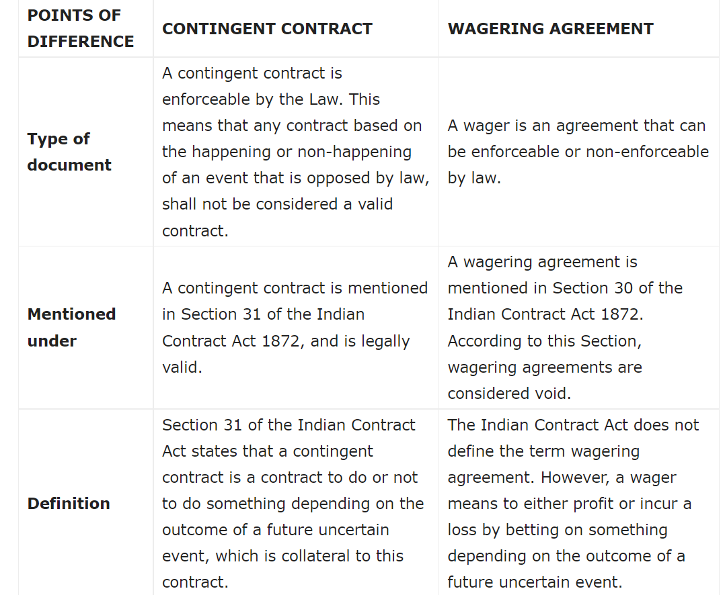

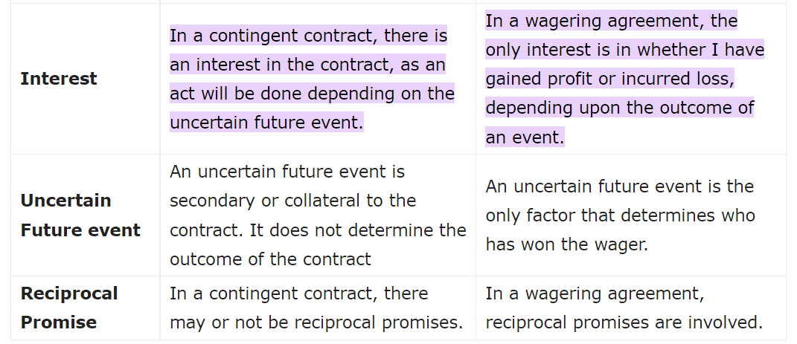

18. What do you mean by performance of a Contract? Describe the requisites of valid tender.

**performance**, in [law](https://www.britannica.com/topic/law), act of doing that which is required by a [contract](https://www.britannica.com/topic/contract-law). The effect of successful performance is to discharge the person bound to do the act from any future contractual liability.

Each party to the contract is bound to perform promises according to the [stipulated](https://www.merriam-webster.com/dictionary/stipulated) terms. In case of any controversy as to the meaning of a promise, the courts have usually decided that a person must perform it as the other party reasonably understood it to be. Thus, a preference for the rights of the one who is to receive the benefit of the promise is established.

A tender is an offer. It is something that invites and intends to invite, acceptance. Sometimes, in the case of large contracts, a list is prepared, tabulated and the names of all contractors who have tendered are displayed; and in front of each name, it indicates the total price offered and also the observations made by the contractor or a particular condition that the contractor wishes to regulate its execution of the work.

**Requisites of valid tender**

A tender is an offer. It is something that you invited and communicated to notify acceptance. In general terms, the following are the requirements of a valid offer:

1. It must be unconditional - If the offer is accompanied by a condition that prevents it from being perfect or complete in itself, it cannot be considered as an equivalent payment and the promisee is not obliged to accept it and in a Lahore case, the plaintiff sent a single check for two items, only one of which was due at that time and the other was not due for a few years.
2. It must be done in the right place - The tender must be made in the place stipulated in the compliance contract, or if a provision is not made, then in the place determined by law.
3. They must conform to the terms of the obligation - The offer must conform to the terms of the obligation. The offer must be made in a complete and early manner exactly how the promisor has accepted. The matter can be initiated by [Karsale (Harrow) Ltd v. Wallis](https://en.wikipedia.org/wiki/Karsales_(Harrow)_Ltd_v_Wallis" \t "_blank), where the defendant inspected a Buick car that subsequently wanted to sell and found that it was in excellent condition. Subsequently, the defendant signed a contract of purchase and contracting with respect to C.
4. It must be done at the right time - The tender must be made in a timely manner. Therefore, it has been argued that an offer of debt before the due date is not an impediment and will not prevent interest from accruing on the debt.
5. It must be done in the proper way - To be valid, the tender must be in the proper form. The payment must be offered in what is called **“legal tender”**, in the currency of the country or in the currency of the tickets.
6. The person making the bid must be able and willing to fulfil their obligation - Another essential requirement of a valid offer is that it must be done in such circumstances so that the person to whom it is made can have a**reasonable opportunity** to make sure that the person by whom it is done can and is willing to do so and there is the whole.
7. There must be a reasonable opportunity for inspection - The seller is obliged to ask the buyer for a reasonable opportunity to examine the goods in order to determine if they are in accordance with the contract. The interested party could not make an inspection of the goods that do not comply with the requirements of the law. However, there is no authority for the proposition that a buyer has the right to continue inspecting and examining until the expiration of the delivery period.
8. The tender must be made to the right person - An offer to be effective must be made to the right person. At first glance, it is the fiancé who can demand payment and deliver a valid receipt, even though he may have been hired for the benefit of others.
9. It must be of the total amount - The offer must be of the total amount owed. An offer obstructed with the equipment that the money should be taken as an agreement is not valid.

19. What are Reciprocal Promises? Explain its rules.

**Section 57 in The Indian Contract Act, 1872**

57. Reciprocal promise to do things legal, and also other things illegal.—Where persons reciprocally promise, firstly to do certain things which are legal, and secondly, under specified circumstances, to do certain other things which are illegal, the first set of promises is a contract, but the second is a void agreement. —Where persons reciprocally promise, firstly to do certain things which are legal, and secondly, under specified circumstances, to do certain other things which are illegal, the first set of promises is a contract, but the second is a void agreement."

## Rules

**1.** Sec. 51 states, when a contract consists of reciprocal promises to be performed simultaneously, no promisor need to perform his promise unless the promise is ready and willing to perform his reciprocal promise.

**2.** According-to Sec. 52, where the order in which reciprocal promises are to be performed, is expressly fixed by the contract, they must be performed in that order, and where the order is not expressly fixed by the contract, they must be fixed in the order which the nature of the transaction requires.

**3.** When a party to the contract prevents the other from performing the promises the contract becomes voidable on the option of the party so prevented and he is entitled to compensation from the other party for any loss which he may sustain in consequence of the non-performance of the contract. (Sec. 53)

**4.** According to Sec. 54, when a contract consists of such reciprocal promises that one of them cannot be performed till the other has been performed and the promisor of the promise last mentioned, fails to perform it, he cannot claim the performance of the reciprocal promise.

**5.** If time is the essence in a mutual contract and the promise is not performed at the time prescribed by the promisee, the other party may assume that the contract is terminated. (Sec. 55)

**6.** Any reciprocal agreement to do an act, performance of which is impossible since beginning, is void under Sec. 56.

**7.** Sec. 57 says, when a contract consists of two parts-one part is legal and the other illegal and the legal part is separate from the illegal one, the first act of promise is a contract, and therefore, enforceable, but the second is void agreement being illegal.

**8.** In the case of alternate promise, one branch of it being legal and the other illegal, the legal branch alone can be enforced. (Sec. 58)

20. Explain the Essence of Time in the performance of a contract.

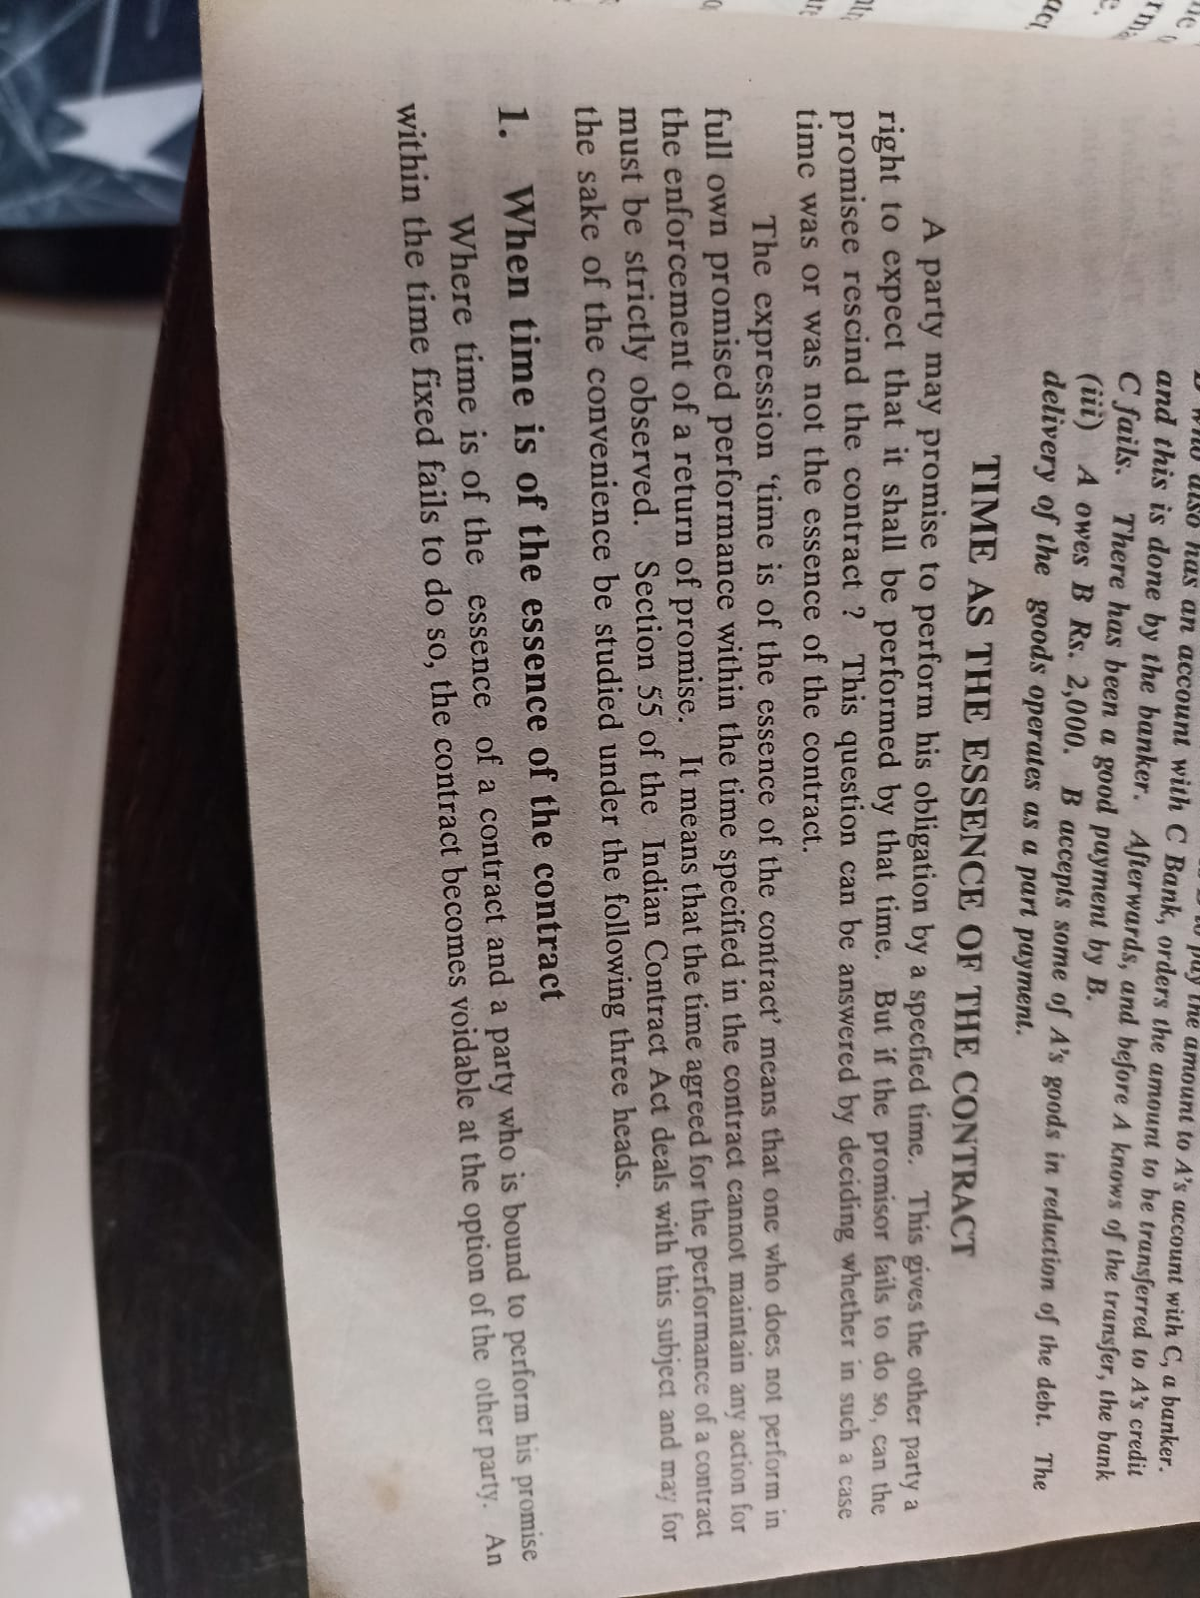

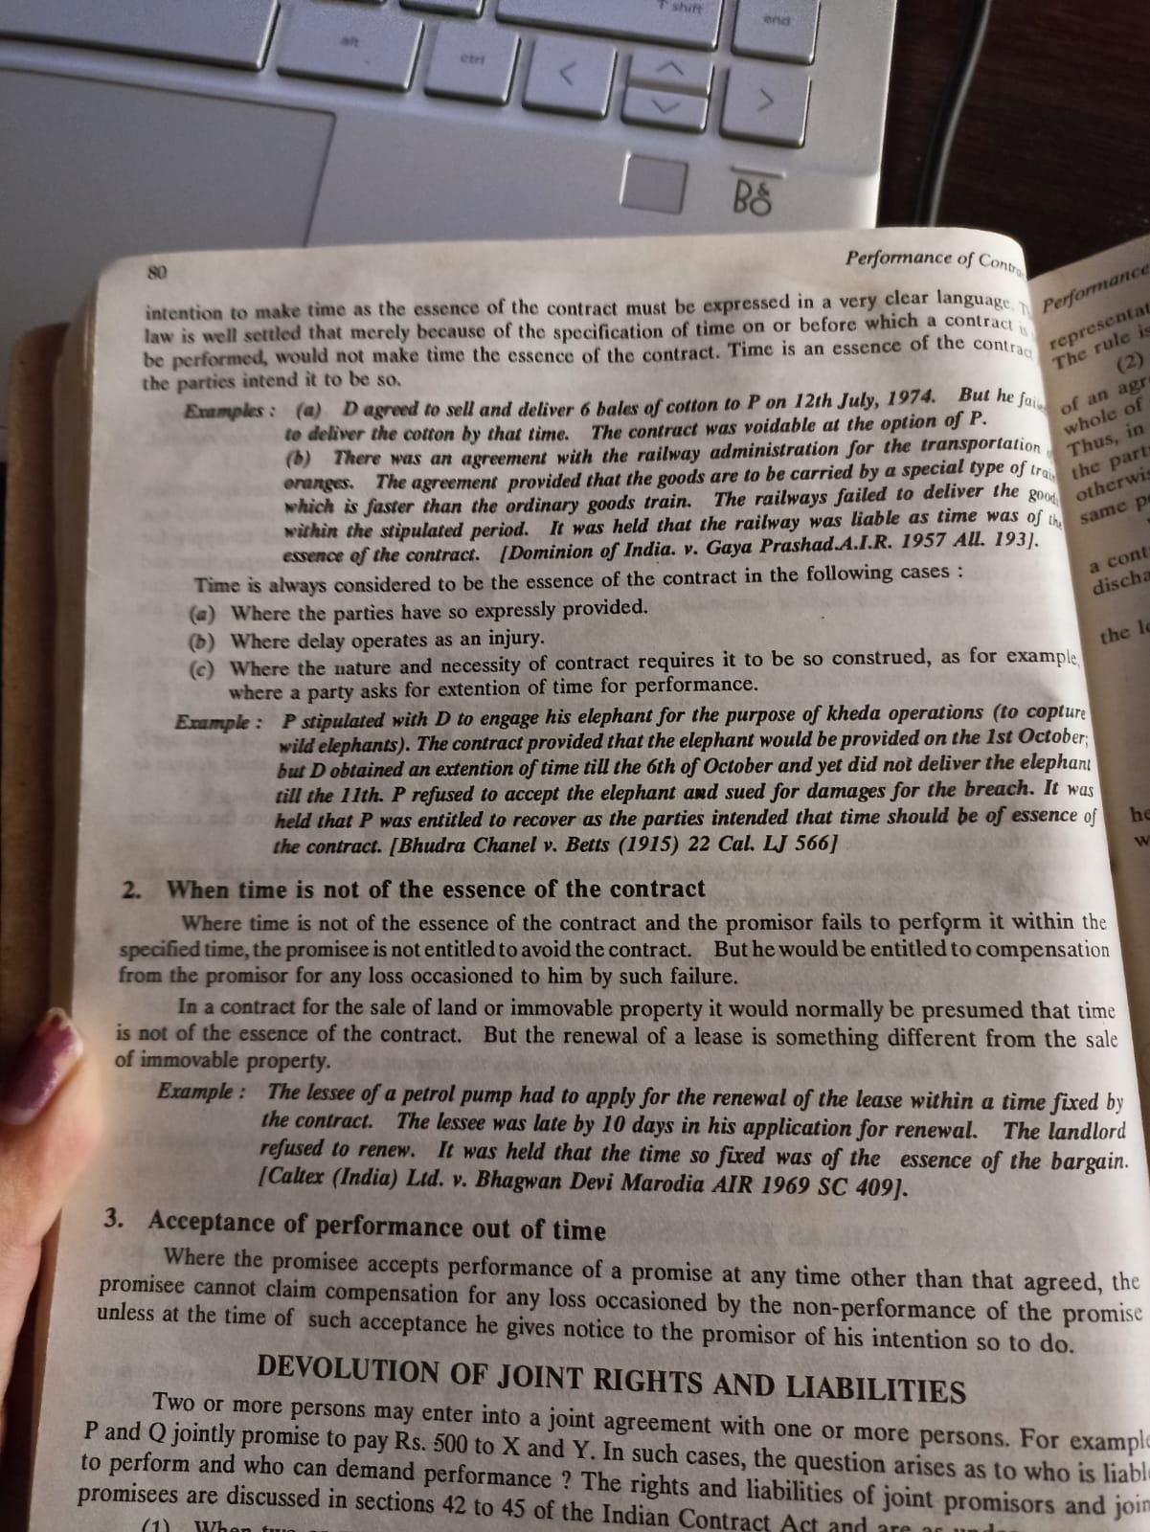

21. Explain the various modes of discharge of a contract.

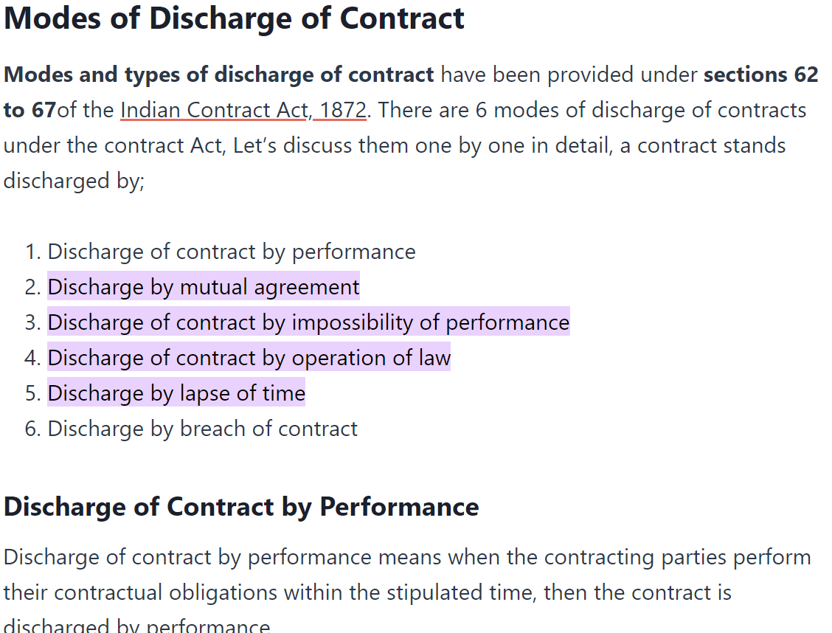

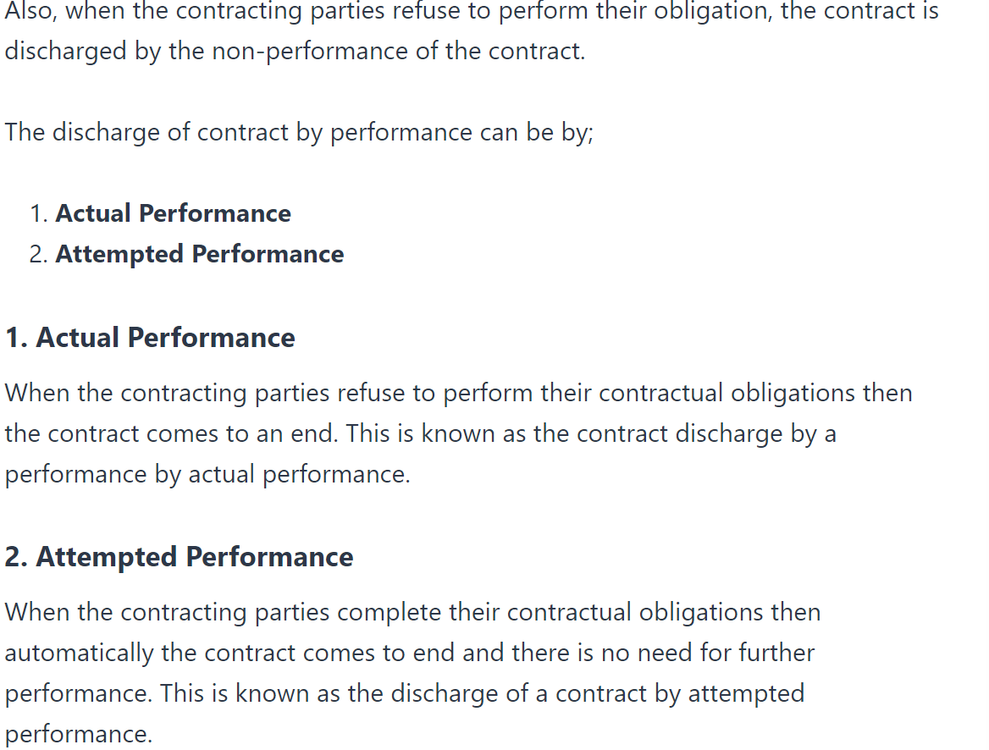

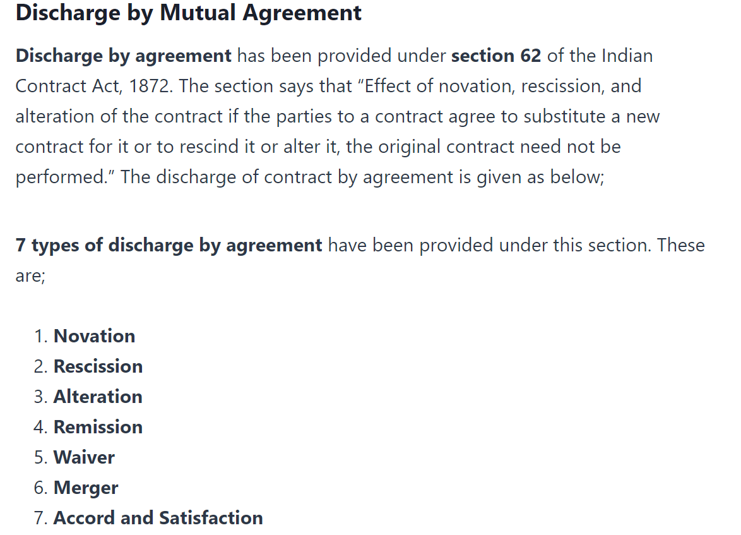

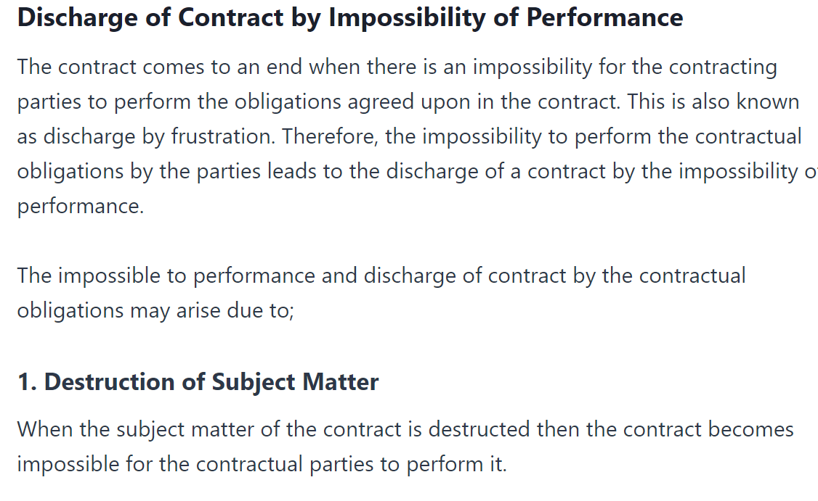

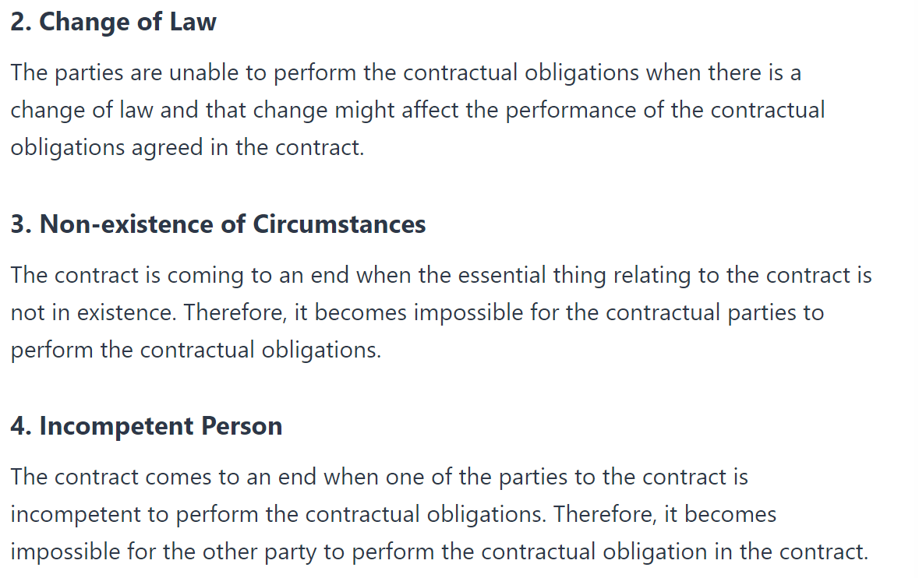

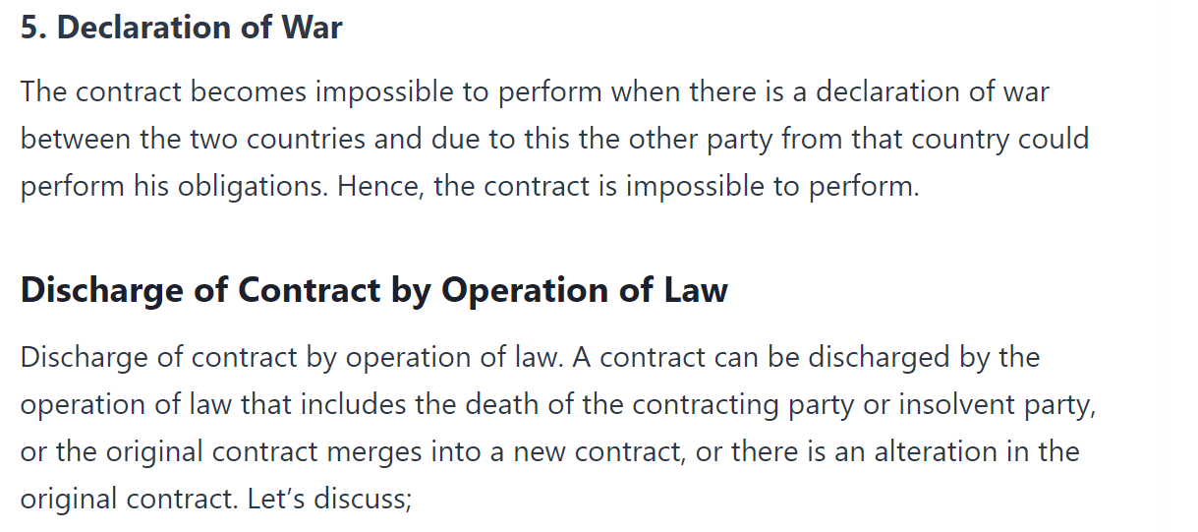

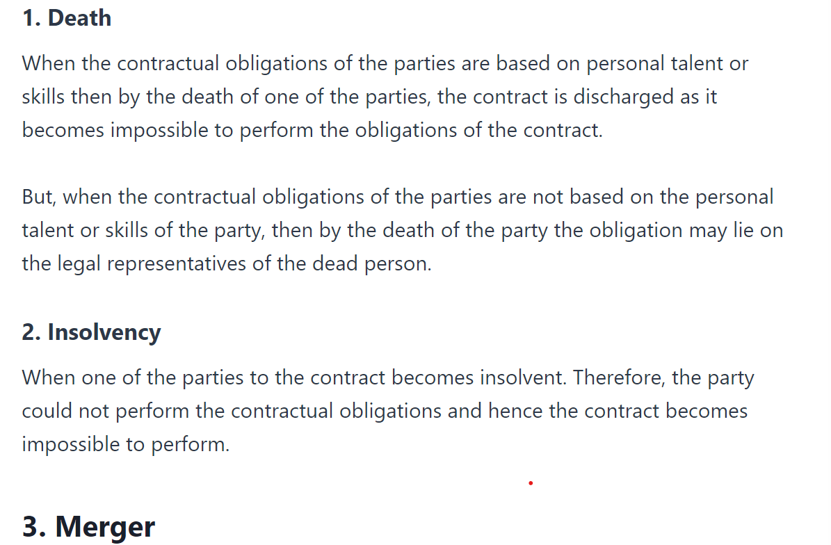

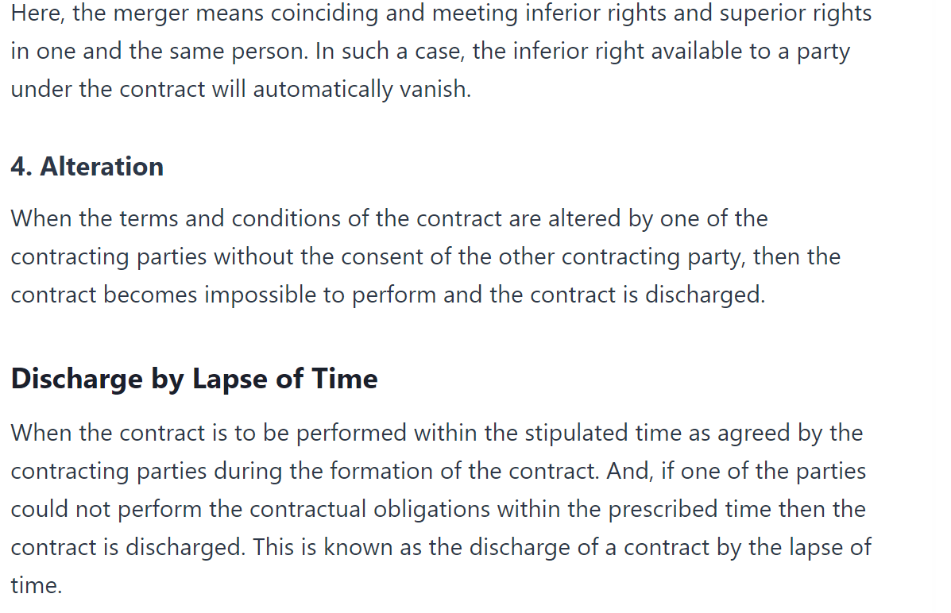

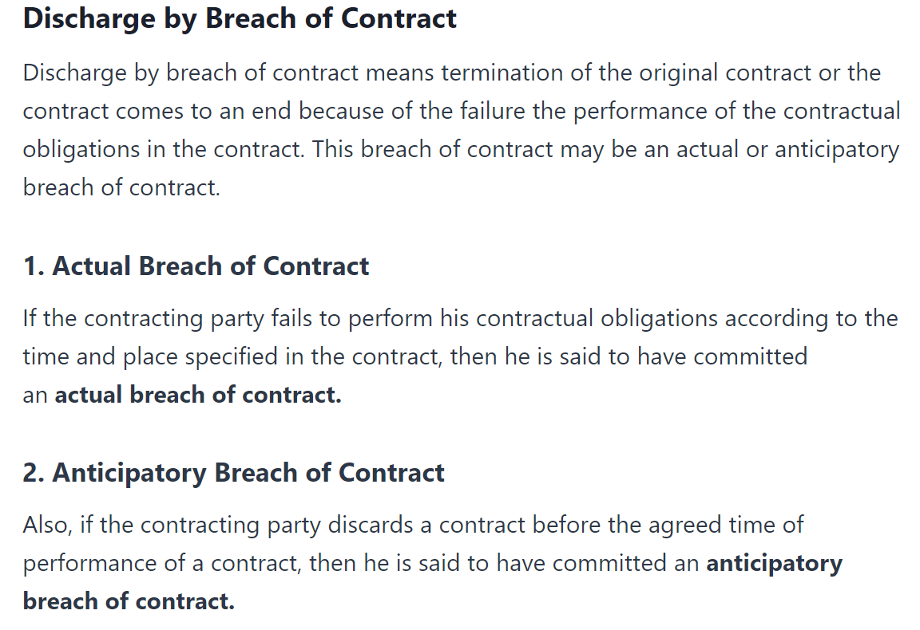

22. When an contracts said to be discharged under mutual agreement?

If both the parties to the contract, expressly or impliedly, agree to terminate the contract, the contract is said to have been discharged by mutual consent.

**Example**: A buys a scooter from B with the condition that if it’s working is not found satisfactory, he will return it within 10 days. A is not satisfied with the performance of the scooter and returns it to B within 10 days. The contract is discharged by mutual consent.

Ways Mutual discharge of contract takes place

Mutual discharge of a contract may take place in any of the following ways:

1. **Novation**: Novation means substitution of a new contract in place of the old one. It creates a new contract in exchange of the old contract. It discharges the old i.e., the original contract. New contract here may be either between the same parties or between different parties, the consideration being mutually the discharge of the old contract.

2. **Alteration**: Alteration of a contract means change in one or more of the terms of a contract. Alteration is valid, if it is done with the consent of all the parties to the contract. In such a case, the old contract is discharged.

3. **Remission**: Remission means the acceptance of less than what was contracted for.

4. **Rescission**: Rescission means cancellation of all or some of the terms of a contract. It may occur under various circumstances such as

1. By mutual consent of the parties, or
2. Where a party to a contract fails to perform his obligations, the other party can rescind the contract without prejudice to his rights to receive compensation for breach of contract.
3. In case of a voidable contract, one of the parties has the option to rescind it.

5. **Waiver**: Waiver means “Abandoning” the rights. When a party to the contract abandons or waives his rights, the contract is discharged. Here, both the parties mutually agree that they shall no longer be bound by the contract. It amounts to a release of parties from their contractual obligations.

6. **Merger**: Merger denotes coinciding and meeting of an inferior and superior right in one and the same person. In such a case, inferior right available to a party under an agreement will vanish automatically.

23. Discuss the effect of supervening impossibility on the performance of a contract.

24.”Impossibilty of performance is, as a rule, not an excuse for non-performance of a contract”. Discuss.

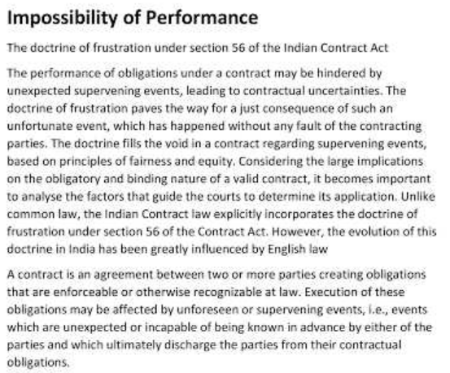

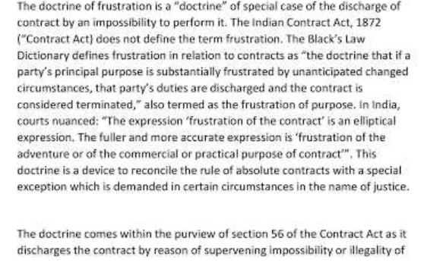

25. What are the remedies available to an aggrieved party on the breach of a contract?

## Remedies for Breach of Contract

When a promise or agreement is broken by any of the parties we call it a breach of contract. So when either of the parties does not keep their end of the agreement or does not fulfil their obligation as per the terms of the contract, it is a breach of contract. There are a few remedies for breach of contract available to the wronged party. Let us take a look.

### ****1] Recession of Contract****

When one of the parties to a contract does not fulfil his obligations, then the other party can rescind the contract and refuse the performance of his obligations.

As per section 65 of the Indian [Contract Act](https://www.toppr.com/guides/business-laws/indian-contract-act-1872-part-i/what-is-a-contract/), the party that rescinds the contract must restore any benefits he got under the said agreement. And section 75 states that the party that rescinds the contract is entitled to receive damages and/or compensation for such a [recession](https://www.toppr.com/guides/general-awareness/money-and-money-market/recession/).

### ****2] Sue for Damages****

Section 73 clearly states that the party who has suffered, since the other party has broken promises, can claim compensation for loss or damages caused to them in the normal course of [business](https://www.toppr.com/guides/business-studies/nature-and-purpose-of-business/concept-and-characteristics-of-business/).

Such damages will not be payable if the loss is abnormal in nature, i.e. not in the ordinary course of business. There are two types of damages according to the Act,

* [Liquidated Damages](https://www.toppr.com/guides/business-laws/indian-contract-act-1872-part-ii/liquidated-damages-and-penalty/): Sometimes the parties to a contract will agree to the amount payable in case of a breach. This is known as liquidated damages.
* Unliquidated Damages: Here the amount payable due to the breach of contract is assessed by the courts or any appropriate authorities.

### ****3] Sue for Specific Performance****

This means the party in breach will actually have to carry out his duties according to the contract. In certain cases, the courts may insist that the party carry out the agreement.

So if any of the parties fails to perform the contract, the court may order them to do so. This is a decree of specific performance and is granted instead of damages.

For example, A decided to buy a parcel of land from B. B then refuses to sell. The courts can order B to perform his duties under the contract and sell the land to A.

### ****4] Injunction****

An injunction is basically like a decree for specific performance but for a negative contract. An injunction is a court order restraining a person from doing a particular act.

So a court may grant an injunction to stop a party of a contract from doing something he promised not to do. In a prohibitory injunction, the court stops the [commission](https://www.toppr.com/guides/maths/compairing-quantities/discount-and-commission/) of an act and in a mandatory injunction, it will stop the continuance of an act that is unlawful.

### ****5] Quantum Meruit****

Quantum meruit literally translates to “as much is earned”. At times when one party of the contract is prevented from finishing his performance of the contract by the other party, he can claim quantum meruit.

So he must be paid a reasonable remuneration for the part of the contract he has already performed. This could be the remuneration of the services he has provided or the value of the work he has already done.

26. What are damages? Explain various kinds of Damages

**damages**, in [law](https://www.britannica.com/topic/law), [money](https://www.britannica.com/topic/money) compensation for loss or injury caused by the wrongful act of another.

## Types of Damages

Sections 73-75 of the Indian Contract Act, 1872, define remedy by way of damages as the entitlement of the suffering party to recover compensation for losses suffered due to non-performance of the contract. The damages can be of the following types:

### ****1] Ordinary damages****

On the breach of a contract, the suffering party may incur some damages arising naturally, in the usual course of events. Even if the suffering party knew about the likely damages if the contract was breached, he can claim compensation for such losses.

Peter agrees to sell and deliver 10 bags of potatoes to John for Rs 5,000 after two months. On the date of delivery, the [price](https://www.toppr.com/guides/business-economics/determination-of-prices/intro-to-determination-of-prices/) of potatoes increases and Peter refuses to perform his promise. John [purchases](https://www.toppr.com/guides/accountancy/recording-transactions/purchases-journal-and-purchase-return-book/) 10 bags of potatoes for Rs 5,500. He can receive Rs 500 from Peter as ordinary damages arising directly from the breach.

### ****2] Special Damages****

A party to a contract might receive a notice of special circumstances affecting the contract. In such cases, if he breaches the contract, then he is liable for the ordinary damages plus the special damages.

Peter hired the [services](https://www.toppr.com/guides/business-studies/business-services/nature-and-types-of-services/) of John, a goods transporter, to deliver a machine to his factory urgently. He also informed John that his [business](https://www.toppr.com/guides/business-studies/nature-and-purpose-of-business/concept-and-characteristics-of-business/) has stopped for want of the machine. However, John delayed the delivery of the machine by an unreasonable amount of time. Peter missed out on a huge order since he didn’t have the machine with him.

In this case, Peter can claim compensation from John. The compensation amount will include the amount of profit he could have made by running his factory during the period of delay. However, he cannot claim the profits that he would have made if he got the contract since John was not made aware of the same.

### ****3] Vindictive or Exemplary Damages****

There are two scenarios for awarding vindictive or exemplary damages:

* Breach of a promise to marry because it causes injury to his/her feelings
* Wrongful dishonour of cheque by a banker because it causes loss of reputation and credibility.

In case of a wrongful dishonour of cheque from a businessman, the compensation will include exemplary damages even if he has not suffered any financial loss. However, a non-trader is not awarded heavy compensation unless the damages are alleged and proved as special damages.

Example: Peter is a farmer. He issues a cheque for procuring seeds for his next crop. He has sufficient funds in his account but the bank erroneously dishonours the cheque. Peter files a suit claiming compensation for damages to his reputation. The Court awards a nominal amount as damages since Peter is not a trader.

### ****4] Nominal Damages****

If a party to a contract files a suit for losses but proves that while there has been a breach of contract, he has not suffered any real losses, then compensation for nominal damages is awarded. This is done to establish the right to a decree for a breach of contract. Also, the amount can be as low as Re 1.

### ****5] Damages for Deterioration caused by Delay****

In cases where goods are being transported by a carrier and he delays the delivery of goods causing them to deteriorate, the affected party can file a suit for damages for deterioration by the delay. Deterioration can mean physical damage to the goods and/or loss of a special opportunity for sale.

### ****6] Pre-fixed damages****

During the formation of a contract, the parties might stipulate payment of a certain amount as compensation upon the breach of the contract. This amount can be a reasonable estimate of the likely loss in case of a breach or a penalty.

Under Section 74 of the Indian Contract Act, 1872, it is specified that if an amount is mentioned in a contract as the sum to be paid in case of a breach, then the suffering party is entitled to reasonable compensation, not exceeding the amount specified.

27. Distinguish between sale and agreement to sell.

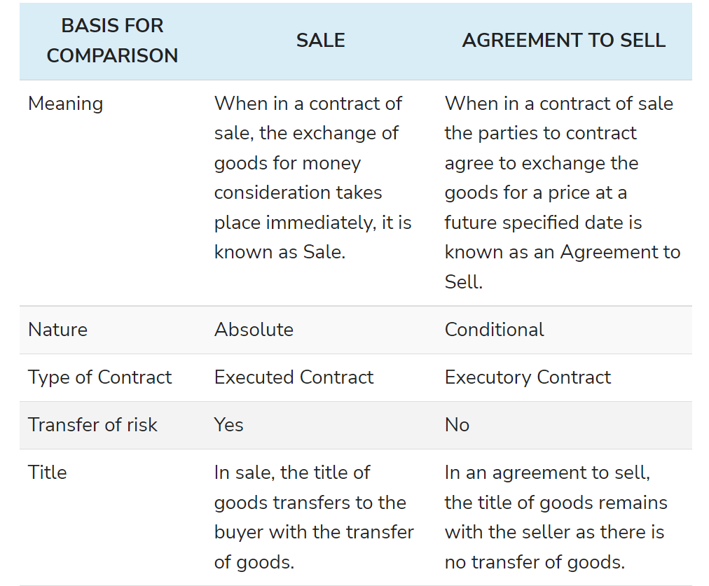

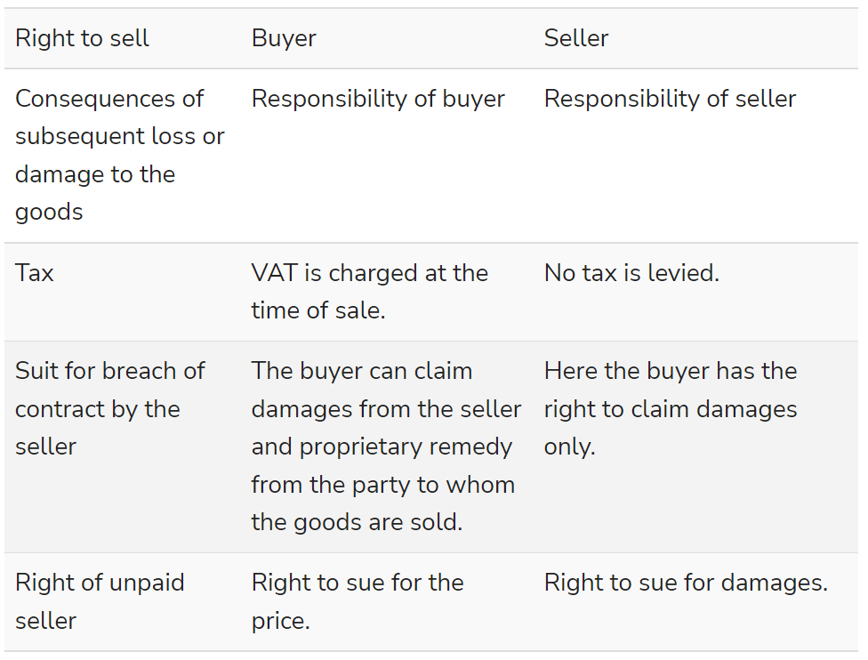

28. Define goods. What are the different types of goods?

*In business law, the term "goods" refers to all movable property apart from actionable claims and money.*

This includes growing crops, grass, and other things attached to land or forming a part of the land, as well as stocks and shares. There are three main types of goods: existing goods, future goods, and contingent goods.

## Existing Goods

Existing goods are goods that physically exist and belong to the seller at the time of contract of sale. Existing can be further divided into two categories:

* **Specific Goods:** These are goods that are specifically agreed upon between the seller and buyer at the time of making the contract of the sale. For example, the seller may agree to sell the buyer a specific item bearing a specific number. These are sometimes known as "ascertained goods." This distinction becomes important because of the rules regarding the [transfer of property](https://www.upcounsel.com/transfer-of-rights-in-the-property) between parties.
* **Unascertained goods:** These are goods that are agreed upon at the point of making the contract of sale but are not specifically identified in the contract. For example, a seller may agree to sell a buyer one out of a number of items of the same type (e.g., bags of sugar) without defining which specific item the buyer will receive. As soon as the specific item is defined, for example when being prepared for delivery, this becomes specific, or ascertained goods.

## Future Goods

Future goods are goods that are not yet in existence or that do not yet belong to the seller when the contract of sale is made. This could be goods that are yet to be manufactured or that the seller has not yet acquired. For example, a farmer may agree to sell a buyer all of the milk produced by his/her cows in the coming year. This is called an "agreement to sell." Because the milk does not yet exist at the point of making the contract, it is an example of future goods.

## Contingent Goods

Although contingent goods are a type of future goods, they differ in that they are dependent on a specific contingency. For example, a seller may agree to sell a buyer some specific goods that are due to arrive on a particular ship. If, when the ship arrives, it does not contain those goods, the buyer will still have fulfilled his agreement, because the sale was contingent on the ship containing those specific goods.

29. Briefly explain the conditions and warranties implied by law in a contract for the sale of goods.

Section 14-17 of the Sale of Goods Act, 1930 deal with the implied conditions and warranties attached to the subject matter for the sale of a good which may or may not be mentioned in the contract.

**Implied Condition**

**Condition as to Title [Section 14(a)]**

Section 14(a) of the Sale of Goods Act 1930 explains the implied condition as to title as ‘in the case of a sale, he has a right to sell the goods and that, in the case of an agreement to sell, he will have a right to sell the goods at the time when the property is to pass’.

This means that the seller has the right to sell a good only if he is the true owner and holds the title of the goods or is an agent of the title holder. When a good is sold the implied condition for the good is its title, i.e. the ownership of the good. If the seller does not own the title of the said good himself and sells it to the buyer, it is a breach of condition. In such a situation the buyer can return the goods to the seller and claim his money back or refuse to accept the good before delivery or whenever he learns about the false title of the seller.

CASE LAW: ***Rowland v Divall, 192210*** – The plaintiff had purchased a car from the defendant and was compelled to return it to the true owner after having used it for a while. The plaintiff then sued the defendant for the purchase money, since the defendant didn’t receive the consideration as per the condition of the title of ownership.

**Sale by Description (Section 15)**

Section 15 of the Sale of Goods Act, 1930 explains that when a buyer intends to buy goods by description, the goods must correspond with the description given by the buyer at the time of formation of the contract, failure in which the buyer can refuse to accept the goods.

**Sale by Sample (Section 17)**

When the goods are to be supplied on the basis of a sample provided to the seller by the buyer while the formation of a contract the following conditions are implied:

* Bulk supplied should correspond with the sample in quality
* Buyer shall have a reasonable opportunity to compare the goods with the sample
* The good shall be free from any apparent defect on reasonable examination by the buyer.

**Sale by sample as well as Description (Section 15)**

When the sale of goods is by a sample as well as a description the bulk of the goods should correspond with both, i.e. description and sample provided to the seller in the contract and not only sample or description.

**Condition as to Quality or Fitness (Section 16)**

The doctrine of Caveat Emptor is applicable in the case of sale/purchase of goods, which means ‘Buyer Beware’. The maxim means that the buyer must take care of the quality and fitness of the goods he intends to buy and cannot blame the seller for his wrong choice. However, section 16 of the Sale of Goods Act 1930 provides a few conditions which are considered as an implied condition in terms of quality and fitness of the good:

* When the buyer specifies the purpose for the purchase of the good to the seller, he relied on the sound judgment and expertise of the seller for the purchase there is an implied condition that the goods shall comply with the description of the purpose of purchase.
* When the goods are bought on a description from a person who sells goods of that description (even if he doesn’t manufacture the good), there is an implied condition that the goods shall correspond with the description. However, in case of an easily observable defect that is missed by the buyer while examining the good is not considered as an implied condition.

**Implied Warranty**

**Enjoy Possession of the Goods [Section 14(b)]**

Section 14(b) of the Act mentions ‘an implied warranty that the buyer shall have and enjoy quiet possession of the goods’ which means a buyer is entitled to the quiet possession of the goods purchased as an implied warranty which means the buyer after receiving the title of ownership from the true owner should not be disturbed either by the seller or any other person claiming superior title of the goods. In such a case, the buyer is entitled to claim compensation and damages from the seller as a breach of implied warranty.

**Goods are free from any charge or encumbrance in favour of any third party [Section 14(c)]**

Any charge or encumbrance pending in favour of the third party which was not declared to the buyer while entering into a contract shall be considered as a breach of warranty, and the buyer is be entitled to compensation and claim damages from the seller for the same.

30. Distinguish between conditions and warranties.

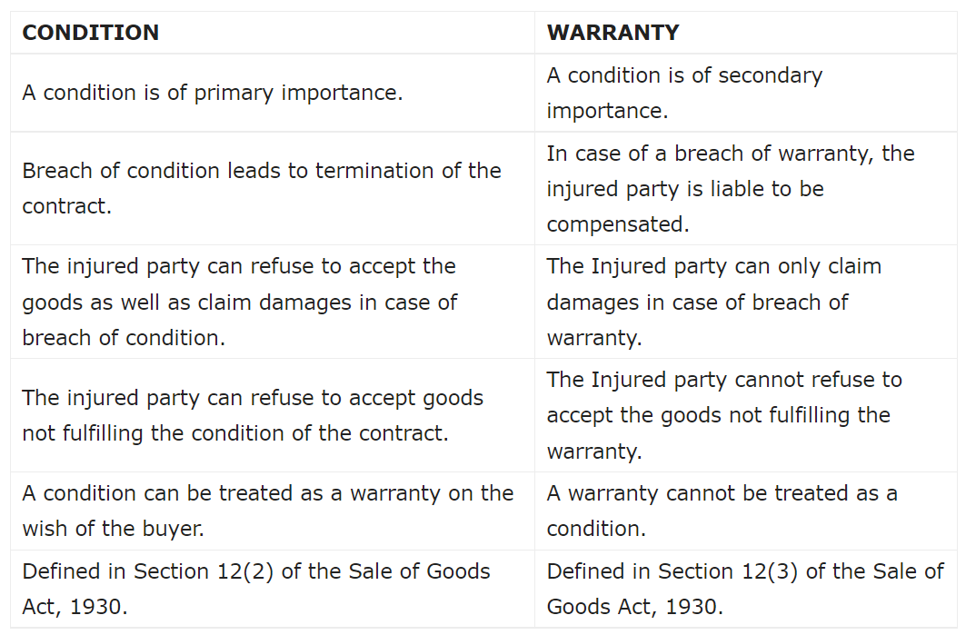

31. State the rules as to passing of property from the seller to the buyer.

Rules Regarding Transfer of Property Under this topic, we will study that in case of different types of goods, when the transfer of property/ ownership in goods takes place from seller to buyer. For this purpose we have two heads:

1. Specific goods and ascertained goods (for both of them rule is same)

2. Unascertained goods and future goods (for both of them rule is same)

1.Specific goods and ascertained goods (for both of them rule is same)

a) Deliverable State The specific/ ascertained goods must be in deliverable state which means the state in which buyer can’t refuse the delivery of the goods and bound to take the delivery of the goods.

Example: Polished furniture is ready for purchase at the showroom. Here, furniture is in deliverable state. Rules: The ownership/property in goods is said to be transferred immediately from the seller to the buyer at the time of contract.

b) Non- Deliverable State The specific/ ascertained goods are not in deliverable state which means some work is still required to be finished before the delivery can be given to the buyer.

Example: Polishing of furniture is required before delivery of the goods. So, here goods will be in deliverable state once the polishing is completed. Rule: The ownership/property in goods is said to be transferred from the seller to the buyer once the goods are in deliverable state and the notice for the same is given by seller to the buyer. Till the time it’s in non-deliverable state, then the ownership lies with the seller only.

c) Price / weight/ measurement of the goods yet to be determined Pricing/ weight/ measurement of the specific/ ascertained goods is not known at the time of contract so, till the time it is not known the ownership remains with the seller.

Rules: The ownership/property in goods is said to be transferred from the seller to the buyer at the time when price/ weight/ measurement of the goods is determined and the notice for the same is given by seller to the buyer.

d) Where goods are delivered on Approval Basis Rules: The property in goods passes from seller to the buyer: à When buyer gives his approval or acceptance to the seller or does any other act of giving approval to the transaction like, consumes the goods, resells the goods to third party etc. à When buyer does not gives his approval or acceptance to the seller but retains the goods without giving the notice of rejection beyond the time fixed for the return and if no time is fixed, after the expiry/ lapse of the reasonable time.

2.Unascertained goods and future goods (for both of them rule is same)

a) Ascertainment of Goods Firstly, unascertained goods need to be ascertained, then only the ownership transfers from seller to the buyer. Till the time goods are unascertained the ownership remains with the seller.

Example: A agrees to sell B, 10 litres of Mustard Oil from the 100 litres of oil available with A. B agrees and paid the price for the same to A. So, here till the time 10 litres oil is separated from the 100 litres of oils available, it will be called unascertained goods and property in goods does not pass to B. It remains with A (seller).

Rule: Firstly, goods need to be ascertained, then only the ownership transfers from seller to the buyer. Till the time goods are unascertained the ownership remains with the seller.

b) Unconditional Appropriation of Goods Seller and buyer mutually selects the goods for the buyer without any condition attached to it or gives consent mutually for selecting the goods.

Essentials of Valid Appropriation:

* 1. Selection of goods
  2. Selection of goods may be based on sample or description provided
  3. Goods must be in deliverable state iv) Consent by buyer and seller- express or implied

32. What do you meant by sale by Non-owners? Give exceptions.

Nemo Dat Quod Non-Habet (Sale by Non Owners)

Basically, Nemo Dat Quod Non-Habet means that seller should have the ownership of goods in order to sell them to the buyer. But, there are few exceptions to it (which means even non-owners can sell even if they don’t have the ownership of goods).

Exceptions to Nemo Dat Quod Non-Habet:

1. Sale by estoppel - A statement or conduct leads the buyer to believe that the person selling the goods has the authority to sell them. And the actual owner don’t show any objection regarding the sale transaction. This will be considered sale by estoppel if below mentioned conditions are fulfilled:

a. The actual owner don’t show any objection regarding the sale transaction

b. Buyer acted in good faith (buyer don’t have any doubt)

2. Sale by mercantile agent - Mercantile agent is a person who is appointed by principal to do some acts on his behalf. So, mercantile agent can sell the goods on behalf of principal even if he is not the actual owner of the goods. But below mentioned conditions should be fulfilled by mercantile agent:

a. Possession of goods with consent of principal

b. Acting in ordinary course of business (following lawful ways to sell the goods)

c. Buyer acted in good faith (buyer don’t have any doubt)

d. No notice of no authority to sell given by principal

3. Sale by joint owner –

Example: There are two persons A & B who jointly owns a Gold Bar. They will be called joint owners. Here, both of them are owners. Ownership is divided between them. If one owner want to sell gold bar then below mentioned conditions needs to be fulfilled:

1. Sole possession of goods with other joint owners consent
2. Buyer acted in good faith (buyer don’t have any doubt)
3. No notice of no authority to sell
4. Sale by person in possession of goods under voidable contract - We have already done voidable contract. Now only explaining this point here. If the cheated party do not take any action then the other party who has obtained the goods by coercion/ undue influence etc. can sell the goods provided below mentioned conditions are fulfilled:
   1. Possession of goods under voidable contract (through coercion, undue influence etc) by other party
   2. Goods sold before contract is cancelled by cheated party
   3. Buyer acted in good faith (buyer don’t have any doubt)
5. Sale by seller in possession of goods after sale –

Example: A has sold goods to B however A has not made delivery of goods to B that means A still possesses the goods and sold the same goods to C. Here, this is only possible that A can sell goods to C if below mentioned conditions are fulfilled:

* 1. Continues to have the possession of goods (that means A still has the possession of goods which is being sold to B. And now he is selling it to C)
  2. Buyer has no knowledge of the previous sale (that means C does not have the knowledge of sale between A and B)
  3. Buyer acted in good faith (buyer- C in this case, don’t have any doubt)

1. Sale by buyer before transfer of ownership –

Example: A has not sold the goods to B but only delivered the goods to B that means only the possession of goods is transferred. So, here this does not make “B” a buyer and “A” a seller. There is only bailer (A) and bailee (B) relation created and A remains the actual owner. But still B sold the goods to C, and this transaction is valid if the below mentioned conditions are followed and hence, C will become the actual owner of the goods:

* 1. Buyer (B) possesses goods with the consent of seller (A)
  2. New buyer ( C) has no knowledge of the transaction happened between A and B
  3. New buyer acted in good faith (buyer don’t have any doubt)

1. Sale by unpaid seller –

An unpaid seller can take the goods back and resell those goods even if, now unpaid seller is not the actual owner.

Example: A sold and delivered goods to B. But B didn’t paid the amount to A for goods. So, here A can take back the goods from B and resell them to another person even if now he is not the actual owner.

1. Exceptions under other acts/ provisions –
   1. Sale of goods/ property by official receiver or liquidator of an insolvent person In this case, official receiver or liquidator of an insolvent person is not the actual owner but still can make the sale of goods/ property of insolvent person.
   2. Finder of goods If finder of goods is not able to find the actual owner of the goods or the expenses to be borne by finder of the goods is very high to keep the goods safe, then finder of the goods has the right either to dispose off those goods or sell them to another person even if finder of the goods is not the actual owner.
   3. Sale by pawnee under pledge

Example: A (Pawnor) has taken loan from B (Pawnee) for Rs. 10,000 by pledging the GOLD as security. If A does not repay the amount to B then B has the right to recover the amount of loan by selling gold to another person even if B is not the actual owner of the goods.

33. Describe the rules of Delivery of goods under the contract of sale of goods.

**Rules for Delivery of Goods**

Following are the [rules for delivery of goods](https://www.geektonight.com/rules-for-delivery-goods/#rules-for-delivery-of-goods):

1. [Delivery and Payment are Concurrent Conditions](https://www.geektonight.com/rules-for-delivery-goods/#delivery-and-payment-are-concurrent-conditions)

Unless otherwise agreed, delivery of goods and payment of price are concurrent conditions. In other words, the seller shall be ready and willing to give the possession of the goods to the buyer in exchange for the price and the buyer shall be ready and willing to pay the price in exchange for possession of the goods. For example, in a cash sale both the parties perform their respective obligations simultaneously.

1. [Modes of Delivery](https://www.geektonight.com/rules-for-delivery-goods/#modes-of-delivery)

Irrespective of the mode of delivery whether actual, symbolic or constructive, it must have the effect of putting the goods in the possession of the buyer or his authorized agent.

1. [Effect of Part Delivery](https://www.geektonight.com/rules-for-delivery-goods/#effect-of-part-delivery)

Section 34 of Sale of Goods Act lays down two rules in this regard, which are as follows:

1. Where the part delivery is made in progress (in continuation) of the whole delivery, then it is treated as a delivery of whole and the ownership of the whole quantity is supposed to pass to the buyer.
2. Where the part delivery is made with the intention of separating it from the whole lot, then such part delivery does not operate as delivery of the remainder part also. It means that delivery of a severed (separated) part is not treated as a delivery of the whole and therefore the ownership of the whole quantity is not transferred to the buyer such part of goods is delivered to him.
3. [Buyer to Apply for Delivery](https://www.geektonight.com/rules-for-delivery-goods/#buyer-to-apply-for-delivery)

Section 35 of Sale of Goods Act provides that if there is no express agreement between the parties to its contrary, the seller of goods is not bound to deliver them until the buyer applies for delivery. Thus, it is a statutory obligation on the buyer to call upon the seller to perform delivery.

1. [Place of Delivery](https://www.geektonight.com/rules-for-delivery-goods/#place-of-delivery)

According to Section 36(1) of Sale of Goods Act, whether the buyer is to take possession of the goods or the seller is to send them, is a question that depends upon the terms of the contract and therefore it will differ from case to case.

1. [Time of Delivery](https://www.geektonight.com/rules-for-delivery-goods/#time-of-delivery)

Where the place of delivery is agreed upon, the goods are delivered at that place during business hours on a working day. Section 36 (2) of the Act provides that where the seller is bound to send the goods to the buyer under the terms of the contract but no time for sending them is fixed, the seller is bound to send them within a reasonable time.

1. [Acknowledgement by a Third Person](https://www.geektonight.com/rules-for-delivery-goods/#acknowledgement-by-a-third-person)

Section 36(3) of the Act lays down that where the goods at the time of the sale are in the possession of a third person, there is no delivery by seller to buyer unless and until such third person acknowledges to the buyer that he holds the goods on his behalf.

1. [Expenses of Delivery](https://www.geektonight.com/rules-for-delivery-goods/#expenses-of-delivery)

Section 36(5) of the Act provides that unless otherwise agreed, the expenses of putting the goods into a deliverable state and also the incidental expenses in this connection both shall be borne by the seller.

1. [Delivery of Wrong Quantity and Quality](https://www.geektonight.com/rules-for-delivery-goods/#delivery-of-wrong-quantity-and-quality)

Section 37(4) lays down that if there is no usage of trade, or no special agreement or no course of dealing between the parties, then the following rules shall apply when delivery of wrong quantity and quality is made:

* **When quantity is short**
* **When quantity is in excess:**
* **When the quality is mixed:**

1. [Instalment Deliveries](https://www.geektonight.com/rules-for-delivery-goods/#instalment-deliveries)

In the absence of an agreement to the contrary, the buyer is not bound to accept delivery by instalments. [Section 38(1)] Sometimes, there may be a contract where goods sold are to be delivered by separate instalments each of which is to be separately paid for.

1. [Delivery to Carrier or Wharfinger](https://www.geektonight.com/rules-for-delivery-goods/#delivery-to-carrier-or-wharfinger)

In this connection there are the following rules:

1. Where the seller is authorised or required to send the goods to the buyer, the delivery of the goods to a carrier for the purpose of transmission to the buyer of the delivery of the goods to a wharfinger for safe custody, is prima facie deemed to be a delivery of the goods to the buyer. Section 39(1)
2. It is the duty of the seller to make with the carrier or the wharfinger such contract as would sufficiently protect the buyer’s interest in the goods. If he fails in his duty and the goods are lost or damaged, then the buyer may hold the seller liable for damages or he may refuse to treat the delivery to the carrier or the wharfinger as delivery to himself. Section 39(2)
3. Unless otherwise agreed, in cases where goods are sent to the buyer by a route involving sea transit and it is usual to get them insured, then it is the duty of the seller to give such notice to the buyer so as to enable him to insure the goods. If the seller fails to do so, the goods shall be deemed to be at his risk during the sea transit.
4. [Buyer’s Risk for Deterioration of Goods in Transit](https://www.geektonight.com/rules-for-delivery-goods/#buyers-risk-for-deterioration-of-goods-in-transit)

According to Section 40 of the Sale of Goods Act, where goods are delivered at a distant place, the liability of such deterioration in the goods as is necessarily incidental to the course of transit, will fall on the buyer even though the seller agrees to deliver them at his own risk.

1. [Buyer’s Right of Examining the Goods](https://www.geektonight.com/rules-for-delivery-goods/#buyers-right-of-examining-the-goods)

Section 41 of the Act lays down that where those goods are delivered to the buyer which he has not previously examined, he is entitled to examine them for his satisfaction. He is not deemed to have accepted them unless and until he has had a reasonable. opportunity for such examination. And unless otherwise agreed, the seller is bound to afford the said opportunity at the time of delivery if the buyer requests for the same.

1. [Acceptance of Delivery by Buyer](https://www.geektonight.com/rules-for-delivery-goods/#acceptance-of-delivery-by-buyer)

According to Section 42 of Sale of Goods Act, the buyer is deemed to have accepted the goods:

1. When he intimates to the seller that he has accepted them.
2. When the goods have been delivered to him and he does any act in relation to them which is inconsistent with the ownership of the seller, for example, he pledges them or resells them.
3. When after the lapse of a reasonable time, he retains the goods-without intimating to the seller that he has rejected them.
4. [Buyer not Bound to Return Rejected Goods](https://www.geektonight.com/rules-for-delivery-goods/#buyer-not-bound-to-return-rejected-goods)

Section 43 of the Sale of Goods Act lays down that unless otherwise agreed, where the buyer refuses to take delivery of the goods and if he has a right to do so, he is not bound to return them to the seller, but it is sufficient if he intimates to the seller that he refuses to accept them.

1. [Liability of Buyer for Neglecting or Refusing Delivery of Goods](https://www.geektonight.com/rules-for-delivery-goods/#liability-of-buyer-for-neglecting-or-refusing-delivery-of-goods)

According to Section 44 of the Act, when the seller is ready and willing to deliver the goods and requests the buyer to take delivery and the buyer does not take delivery within a reasonable time after such request, the buyer is liable to the seller for loss occurred by his neglect or refusal to take delivery; and also for a reasonable charge for the care and custody of the goods.

34. When is a seller of goods deemed to be an unpaid seller? What are his rights?

Features of an unpaid seller

1. Seller must sell the goods on cash basis and must be unpaid (in cash transactions payment becomes due instantly)

2. Seller must be unpaid either wholly or party

3. The decided period has expired and the price has not been paid to seller

4. Seller must not refuse to accept the payment

5. Where the price paid through negotiable instrument (bill of exchange/ promissory note/ cheque) and the same has been dishonoured.

# **Rights against buyer**

## **1- Suit for the price**

When any goods are passed on to the buyer and the buyer has wrongfully neglected or refused to pay as per the terms and conditions of the contract, the seller may sue him as per the [Section 55(1)](https://indiankanoon.org/doc/1971471/)because once the property has been passed the buyer is bound to pay the price. But in the case due date of payment has been passed and goods had not been delivered yet, the seller can sue the buyer for the wrongful neglect or refusal on his part according to [clause 2 of Section 55](https://indiankanoon.org/doc/1971471/).

## **2- Suit for damages**

In case there is a wrongful refusal on the part of buyer for acceptance of goods and payment of money, the seller can sue him for damages of non-acceptance as per [Section 56](https://indiankanoon.org/doc/896079/). For calculating the quantum of damages [Section 73 and 74 of the Indian Contract Act](https://singhania.in/liquidated-damages-section-73-section-74/)applies. In case the goods have a ready market, the seller has to resell the goods and buyer have to pay the losses if incurred. If the seller does not resell the goods the difference between contract and market price at the day of breach is taken as a measure for damages. If the difference between them is nil seller gets nominal value.

## **3- Suit for interest**

As stated under [Section 61](https://indiankanoon.org/doc/741531/), where there is a specific agreement between buyer and seller with regards to interest on the price of goods from the date on which payment becomes due, the seller may recover interest from a buyer. But if there were no such agreement the seller may charge interest from the day he notifies the buyer. If there is no contract to the contrary, the court of law may award interest to the seller at such rate as it thinks fit on the amount of the price from the date on which amount is payable.

# **Rights against goods**

## **a- Lien**

Lien is a right which seller of goods can exercise when a buyer has not paid the price of goods, under this right seller can retain the possession of goods as an agent or bailee for the buyer. The seller can retain his possession as per [Section 47](https://indiankanoon.org/doc/1218839/)under the following circumstances:

1- In case the buyer is insolvent.

2- When the term of goods sold on credit is expired.

3-  Goods sold without any stipulation as to credit.

When the goods are sold on credit the right to lien is suspended during the term of credit and lien exist only for the price of goods, not any additional charges.

## **b- Stoppage**

When the goods have been transferred to carrier or bailee for the purpose of transmission to the buyer, who has become insolvent, the seller has the right to stop the goods in transit in order to protect himself against the loss that may arise due to insolvency. As per Section 50, there are four essential requirements for stopping the goods in transit:

1. Unpaid seller.
2. Buyer insolvent.
3. Property should have passed to the buyer.
4. Property should be in course of transit.

The course of transit depends upon the capacity of middleman to hold the goods. Middleman should be an intervening person between the seller who has parted with the goods and the buyer who has not yet received the goods as held in the case of *[Schotsmans v Lancashire & Yorkshire Rly co.](https://discovery.nationalarchives.gov.uk/details/r/C7883108" \t "_blank)*

## **c- Resale**

Exercising the right of lien or stoppage does not rescind the agreement but reselling of goods does and without this right, the other two rights of lien and stoppage would not be of much usage because he can only retain goods under these right till the buyer pays back the money.

The unpaid seller can exercise his right under following conditions and circumstances-

1- Seller before reselling the goods needs to send a notice to the buyer except in the case of perishable goods, giving him last chance to pay the price and take back the goods within a reasonable time. If the buyer does not pay the money back seller has the right to resell the goods. If the seller fails to give notice of his intention to resell, he cannot claim damages from the buyer and he has to give any profit.

2- If there is any loss in the resale of goods he can claim the loss from the buyer, on the contrary, if there is profit buyer cannot claim it.

3- Seller gives rightful ownership to buyer after the resale it does not matter notice of resale is given or not to defaulted buyer.

4- Sometimes the seller reserves exclusive right to resale the goods if the buyer makes a default in payment, in such cases the buyer cannot ask for profit on resale if no notice is served and seller has the exclusive right to resale.

35. What is Auction Sale? Explain the procedure.

Auction Sale - An auction sale is a public sale. The goods are sold to all members of the public at large who are assembled in one place for the auction. Such interested buyers are the bidders. The price they are offering for the goods is the bid. And the goods will be sold to the bidder with the highest bid.

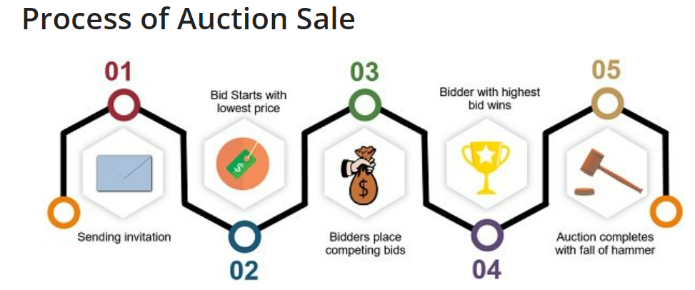

1. The process of auction sale starts with**sending an invitation** to the parties for auction. For this purpose, circulation of an advertisement and catalogue of the goods under auction along with the terms of sale takes place.
2. In this process, the bidders act as competitors and thus **they place competing bids**. In essence, each subsequent bid is higher in price than the last one.
3. When the auctioning begins, the**auctioneer starts with the lowest deal price**. He does so to gather the attention of most of the bidders. The interested buyers offer bids one after another and seek to outbid each other. And so, with each next bid, the price keeps on increasing until it reaches a point where no other bidder offers a higher price than the last one.
4. Therefore, the **item goes to the highest bidder** present at the time.
5. An auction sale is complete when the auctioneer signals it by **the Fall of a Hammer** or any other customary way. And with the Fall of Hammer, the property in goods passes to the highest bidder. And so, until the fall of the hammer, the bidder can revoke his offer, if he wants to.
6. As soon as the vendor accepts the highest bid offered, the auction comes to end. Thereafter, the **buyer has to pay the agreed price** and take possession.
7. After that, the auctioneer can ask for **payment of the sale money via cash**. The buyer cannot compel the auctioneer to accept payment of money by way of a bill of exchange or cheque.

36. What are the objectives of Consumer Protection Act.

# **Objective of the Consumer Protection Act, 2019**

The main objective of the Act is to protect the interests of the consumers and to establish a stable and strong mechanism for the settlement of consumer disputes. The Act aims to:

1. Protect against the marketing of products that are hazardous to life and property.
2. Inform about the quality, potency, quantity, standard, purity, and price of goods to safeguard the consumers against unfair trade practices.
3. Establish Consumer Protection Councils for protecting the rights and interests of the consumers.
4. Assure, wherever possible, access to an authority of goods at competitive prices.
5. Seek redressal against unfair trade practices or unscrupulous exploitation of consumers.
6. Protect the consumers by appointing authorities for timely and sufficient administration and settlement of consumers’ disputes.
7. Lay down the penalties for offences committed under the Act.
8. Hear and ensure that consumers’ welfare will receive due consideration at appropriate forums in case any problem or dispute arises.
9. Provide consumer education, so that the consumers are able to be aware of their rights.
10. Provide speedy and effective disposal of consumer complaints through alternate dispute resolution mechanisms.

37. What are the Consumer Protection Councils organised? Explain

38. Describe the various consumer protection councils. Their formation and objectives.

Following are the consumer protection councils  -

(1) **Consumer Education And Research Center (Gujarat)**- CERC is a recognised consumer organisation by the Government of India and Government of Gujarat. It is dedicated to the cause of consumer protection, environment protection, investor protection and public health and safety issue.

(2)**Bureau Of Indian Standards**- BIS is the National Standard Body of India established under the BIS Act 2016 for the harmonious development of the activities of standardization. The Product Certification Schemes of BIS aims at providing Third Party assurance of quality, safety and reliability of products to the customer.

(3)**Federation Of Consumer Organisation In Tamil Nadu**-Cuddalore District Consumer Protection Organisation is a not-for-profit organisation based in Tamil Nadu which aims to protect the interests of consumers through campaigning, to educate consumers on their rights to legal redressal and to hold workshops and training for consumer activists.

(4) **Mumbai Grahak Panchayat**-Mumbai Grahak Panchayat (MGP) is perhaps the largest voluntary consumer organisation in India with a membership of 24,500 families. It has been engaged in activities of consumer protection and education for the last 33 years. Its unique collective group buying system provides a best practice model for sustainable consumption

(5) **Consumer Voice (New Delhi)**-VOICE is an acronym for Voluntary Organisation in Interest of Consumer Education which has pioneered the protection of consumers in India. Based in New Delhi, the organisation has championed consumer education in the country since 1983.

(6)**Legal Aid Society (Kolkata)**- Legal Aid Services, West Bengal (LASWEB), one of the pioneering legal aid offering civil society organizations in India, empowers the poor and the disadvantaged with varied legal entitlements. Functioning since 1980 as an organic collective of retired judges, practising lawyers and social activists.

(7) **Akhil Bhartiya Grahak Panchayat**-The Pioneer of Indian Consumer Movement, Grahakteerth Hon. Shri Bindumadhav Joshi is the founder of this organization. Inspired by him, Dr. Vijay Lad registered this organization. Grahaktirth Hon. Bindumadhav Joshi is the founder president of Akhil Bhartiya Grahak Panchyat, Freedom Fighter and Ex Minister.

(8) **The Consumers Eye India.**-The Consumer Guidance Society of India (CGSI) is a Non-Profit consumer organization established in [India](https://en.wikipedia.org/wiki/India) in 1966 to protect and educate the Indian consumer about sub-standard products and services, adulterated foods, short weights and measures, spurious and hazardous drugs, exorbitant prices, endemic shortages leading to black marketing and profiteering, unfulfilled manufacture guarantees, and a host of other problems

(9)**United India Consumer's Association**- Consumers Association of India (CAI) is a membership-based organisation with 8,000 registered members all over India. Its main objectives are: spreading consumer awareness; empowering consumers and teaching them their responsibilities and rights as consumers. CAI regularly conducts seminars, workshops and training programmes and publishes various consumer guides on a variety of topics, which are of interest to consumers.

39. What is a Consumer Dispute? How do you file a complaint?

“Consumer dispute” refers to a dispute where a consumer make a complaint against a person and the person denies the allegations contained in the complaint.

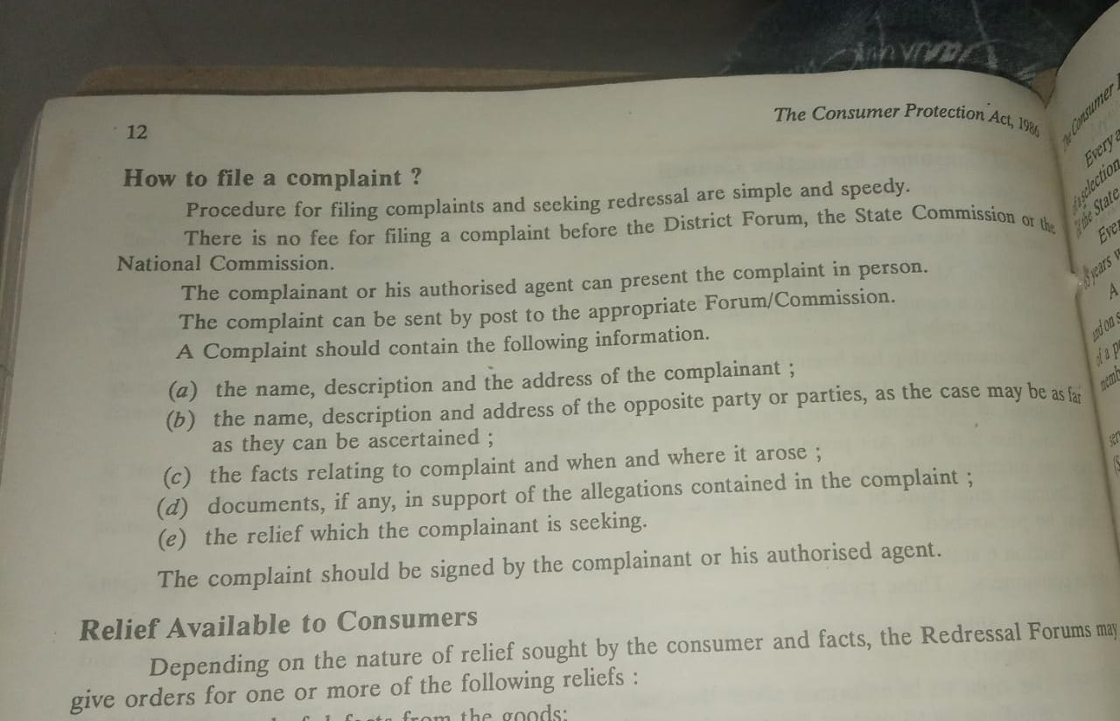

40. What are the various consumer redressal forums? Explain.

41. Who is a Director? What are various kinds of Directors?

The directors are the persons elected by the shareholders to direct, conduct,

manage or supervise the affairs of the company. They manage and control the

overall affairs of the company. The day to day working of the company is left

to other managerial persons appointed for the purpose.

Section 2(34) of the Companies Act, 2013 defines a ‘director’ to mean a director appointed to the Board of a company. According to section 2(10)

Board of Directors of Board in relation to a company means collectively body

of the directors of the company.

## Type of Directors Based on Functions Performed

Types of directors are of two types – executive directors and non-executive directors.

### ****2.1 Executive Directors****

 Executive directors are present internally and are involved in day-to-day functions of the company – s.149(12). They are of two types – Managing Directors and Whole-Time Directors

Managing Director – A director who is the CEO and entrusted with substantial powers of management under s. 2(54) . Whole-Time Director – A director employed on a whole-time basis, not the CEO of the company and is under a special contract, appointed under s.2(94)

### 2.2  Non-Executive Directors

Non-executive directors are external professionals and uninvolved in the everyday activities of the company – s.149(12). They are of two types – independent directors and nominee directors .

Independent Directors – They are appointed to ensure transparency and provide expertise. Must have the following qualifications

* Industrial expertise and knowledge
* Must not have any stock options or stake in the company
* Can only be appointed for a maximum of 5 years and for 2 terms, with a minimum cooldown of 3 years between the terms.

Nominee Directors – Representative of the stakeholders appointed to the board of directors. Must have the following requirements – s.149(7) and s.161(3)

* Must be appointed if provided in the Articles of Association (AoA)
* Tata v. Cyrus – Must have unfettered discretion to protect the interests of both the company and the shareholders

## Types of Directors Based on Appointment

The Companies Act, 2013 allows for 3 types of directors based on appointment to deal with contingencies – Additional Director, Alternate Director and Casual Vacancy Director

### ****3.1 Additional Director****

A company may appoint an additional director under s.161(1) to deal with unexpected or additional work. It must fulfil the following requirements

* Must be provided for in the AoA
* Cannot serve beyond the next Annual General Meeting
* Paul v. City Hospital – Additional Directors cannot be appointed in special circumstances to strengthen majority. You can make the [**Directors in company law**](https://vakilsearch.com/appointment-of-director) by consulting experts in your field.

### 3.2  Alternate Director

* Can be appointed under s.161(2) in the absence of the director for more than 3 months to act on his behalf if provided under AoA
* Can only serve till the managing director returns, cannot serve beyond that poin
* Must be a like for like replacement – only an independent alternate director may fill in for an alternate director

### 3.3  Casual Vacancy Director

* Can be appointed under s.161(4) on the death, resignation, disqualification or incapacity of a director
* Need not be provided for under AoA
* Can only serve till the term of the director who has vacated.
* Only applies to public companies

## Miscellaneous Types of Directors

This section deals with [**classification of directors**](https://vakilsearch.com/blog/appointment-and-qualification-of-a-director/) based on categories which may overlap with earlier categories. This section covers residential directors, women directors and small shareholders directors.

### ****4.1 Residential Directors****

* Provided for in s.149(3) that [**every company**](https://vakilsearch.com/online-company-registration/company-registration-in-pune) must have at least one director who resides in India for at least 182 days in a year
* For newly incorporated companies, the requirement shall apply proportionally (50%) to the end of the FY

### 4.2  Women Directors

* Provided for in s.149(1), requires 3 types of companies to have a minimum of one women director
* Every listed company
* Every public company without a paid up share capital of 100 cr or a turnover of 300 cr.
* Companies registered prior to Companies Act, 2013: **https://www.mca.gov.in/Ministry/pdf/CompaniesAct2013.pdf** shall appoint women directors within an year of this act coming to force, while new companies post-2013 act shall appoint women directors within 6 months of registering.

### 4.3  Small Shareholders Director

* There is no mandate to appoint a small shareholders director under s.151, left up to the company’s discretion
* Companies must fulfil two criteria to be eligible to appoint a small shareholders director
* Must be a public company
* Must have at least 1000 or more small shareholders[.](https://en.wikipedia.org/wiki/Companies_Act_2013)

42. What is DIN? Explain its salient features.

Director Identification Number (DIN) is an unique identification number allotted to an individual who is an existing director of a company or intends to be appointed director of a company as per section 153 & 154 of the Companies

Act, 2013.

Every individual, who is to be appointed as director of a company shall make an application electronically in Form NO. DIR-3. to the Central Government for the allotment of a Director Identification Number (DIN) along with such fees as provided in the Companies (Registration Offices and Fees) Rules, 2014.

Rule 9(1).

● The Central Government shall, within one month from the receipt of the application allot a DIN to the application;

● The DIN allotted to the director is valid for the life time and the same shall not be allotted to any other person.

Section 156 of the Act provides that every existing director shall, within one month of the receipt of DIN from the Central Government, intimate his DIN to all companies wherein he is a director.

Features of DIN

• Director Identification Number (DIN) is of 8 digits.

• Same DIN can be used by the Director in case he changes the company.

• DIN once allotted can be used “n” number of times and days till the DIN holder surrenders it.

* An individual can have only one DIN but he can be the director of 2 or more companies.

43. What is the legal position of a Director? Explain.

the real position of a director is not merely that of an agent, or trustee of managing partner, but a combination of all these positions.

Let us now discuss their position under various headings as follows:

**As Agents**: The company being an artificial person cannot manage its affairs on its own. It has to be entrusted to some human agency known as directors. They are elected representatives of the shareholders and may be termed as agents of the company. The relationship between the company and its directors is that of principal and agent. Therefore, the general principles of the law of agency govern the relations of the company and its directors. As agents, it is their duty to carry on the business with reasonable care and diligence. They must act within the authority conferred upon them by the Act, Memorandum and Articles and while entering into contracts on behalf of the company within the scope of this authority, they will bind the company. In other words, if they act beyond the scope of their authority, they will be held personally liable. However, you should note that the acts done beyond the powers of the directors may be ratified by the shareholders in general meeting of the company provided such acts are not beyond the powers of the company. To bind the company, the directors must act in the name of the company. Directors are the agents of the company and not of the individual shareholders.

**As Trustees**: The ‘trustee’ means a person who holds and manages the property for the benefit of other persons. Though in the strict legal sense, directors are not the trustees of the company, but, to some extent, they have been treated as trustees of the company. They are the custodians of the money and properties of the company and as such are responsible for the proper use of such money and property. If they misuse the money or property, they have to refund or reimburse the same. The directors must exercise their powers in good faith and for the benefit of the company, and not for their own benefit. The directors stand in a fiduciary capacity in relation to the company. The same degree of integrity and standard of conduct is expected from the directors as it is expected from a trustee. You should note that directors are trustees for the company and not of individual shareholders. However, you should remember that directors are not the trustees in the strict sense because unlike a trustee a director does not enter into contracts in his own name. He enters into contracts for the company of which he is a director and he does not hold any property in trust, because the property is held by the company in its own name.

**As Managing Partner**: Directors have been described as the managing partners because on the one hand, they are entrusted with the management and control of the affairs of the companies and on the other hand, they are the shareholders of the company. They manage the affairs of the company for their own benefit as a shareholder and for the general benefit of the company.

But they are not managing partners in the strict sense, because the liability of the director is limited to the value of shares held by him whereas the liability of a partner is unlimited. Further, unlike a partner, a director has no authority to bind the other directors and shareholders.

**As Employees**: Directors are the elected representatives of the shareholders. As such, they are not employees or servants of the company. But under a special contract with the company a director may hold a salaried employment in the company and in that case he will be treated as an employee or servant of the company and he will enjoy all the rights available to an employee.

Thus, it is clear from the above discussion that directors are neither the agents, nor the trustees, nor managing partners, nor employees of the company. In fact, they combine in themselves all these positions. They stand in a fiduciary position towards the company in respect of their powers and capital under their control.

44. What are the various modes of Appointment of Directors?

APPOINTMENT OF DIRECTORS

You know that only individuals can be appointed as directors of the company.

Any person who is competent to contract and has obtained DIN is eligible

for appointment as a director of the company. The discussion on appointment

of a director may be dealt with under the following heads:

1. Appointment of first Directors

2. Appointment by shareholders at general meeting

3. Appointment by the Board of Directors

4. Appointment of Resident Director

5. Appointment of Independent directors

6. Appointment of Director elected by small shareholders.

1) Appointment of First Directors (Section 152): The first directors are

usually appointed by name in the articles or in the manner provided therein.

Where the articles do not provide for the appointment of first directors,

the subscribers to the memorandum, who are individuals, shall be deemed

to be the first directors of the company until the directors are duly

appointed. In case of a One Person Company an individual being member

shall be deemed to be its first director until the director or directors are

duly appointed by the member in accordance with the provisions of this

section.

No appointment without DIN - No person shall be appointed as a

director of a company unless he has been allotted the Director Identification

Number (DIN).

Consent to act as Director - A person appointed as a director shall not act

as a director unless he gives his consent to hold the office as director. The

consent must be filed with the Registrar within thirty days of his appointment

in the prescribed manner.

2) By Shareholders in General Meeting: According to section 152(2)

every director shall be appointed by the company in general meeting except

where the Act provides otherwise. In case of a public company, at least

two-thirds of the total number of directors\* must be rotational directors.

The remaining directors (i.e, one-third or less) should also, unless articles of

the company provide otherwise, be appointed by the company in general

meeting.

3) By Board of Directors: The Board of directors may also appoint directors

in the following cases:

* Additional Directors (Section 161): The Board of directors may,

if authorised by the Articles, appoint additional directors. But care

should be taken to see that the total number of directors including

the additional director does not exceed the maximum number fixed

by the Articles. Such an additional director shall hold office only up

to the date of the next annual general meeting or the last date, on

which the annual general meeting should have been held, whichever

is earlier.

* Alternate Director (Section 161): The Board of directors of a

company may, if so authorised by its articles or by a resolution passed

by the company in general meeting, appoint an alternate director to

act for a director during his absence for a period of not less than

three months from India. However, a person holding any alternate

directorship for any other director in the company shall not be

appointed.

No person shall be appointed as an alternate director for an independent

director unless he is qualified to be appointed as an independent

director under the provisions of this Act.

* Director against a casual vacancy (Section 161): If the office of

any director falls vacant for some reason before the expiry of his term

of office, such a casual vacancy may be filled by the Board of

directors at its meeting according to the regulations of the Articles.

Such a vacancy may be caused by death, resignation, insanity,

insolvency etc. The person who is appointed by the Board to fill up

the casual vacancy, shall hold the office only up to the date up to

which the director in whose place he is appointed, would have held

the office.

* Nominee directors: Subject to the articles of a company, the Board

may appoint any person as a director nominated by any institution

in pursuance of the provisions of any law for the time being in force

or of any agreement or by the Central Government or the State

Government by virtue of its shareholding in a Government company.

4) Appointment of Resident Director: For the first time the Companies

Act, 2013 has introduced the concept of resident director. Sub-section (3)

of section 149 provides that every company shall have at least one director

who has stayed in India for a total period of not less than one hundred

and eighty-two days in the previous calendar year.

5) Appointment of Independent Director: Sub-section (4) of section 149

requires every listed public company to have at least one-third of the total

number of directors as independent directors and the Central Government

may prescribe the minimum number of independent directors in case of

any class or classes of public companies. A managing director or a whole-

time director or a nominee director is not an independent director.

6) Appointment of director elected by small shareholders [151]

A listed company may have one director elected by such small shareholders

in such manner and with such terms and conditions as may be prescribed.

‘Small shareholder’ means a shareholder holding shares of nominal value

of not more than twenty thousand rupees or such other sum as may be

prescribed.

The Ministry of Corporate Affairs, in this regard, has prescribed the rules. Rule

7 of Companies (Appointment and Qualification of Directors) Rules, 2014

requires that a company may appoint small shareholders’ director where a notice

to that effect is given by:

i) not less than one thousand small shareholders; or

ii) one-tenth of the total number of such shareholders, whichever is lower.

45. What are the qualification and disqualification of Directors?

DISQUALIFICATIONS OF DIRECTORS

The circumstances in which a person cannot be appointed as a director of a

company are listed in Section 164 of the Companies Act. A person shall not

be capable of being appointed director of a company if:

* he is of unsound mind and stands so declared by a competent court;
* he is an undischarged insolvent;
* he has applied to be adjudicated as an insolvent and his application is pending;
* he has been convicted by a court of any offence, whether involving moral turpitude or otherwise, and sentenced in respect thereof to imprisonment for not less than six months. However, this disqualification will last only up to five years from the date of expiry of the sentence.

But, if a person has been convicted of any offence and sentenced in respect thereof to imprisonment for a period of seven years or more, he shall not be eligible to be appointed as a director in any company;

* an order disqualifying him for appointment as a director has been passed by a court or Tribunal and the order is in force;
* he has not paid any calls for six months or more in respect of any shares of the company held by him, whether alone or jointly with others;
* he has been convicted of the offence dealing with related party transactions under section 188 at any time during the last preceding five years;
* he has not been allotted DIN.

QUALIFICATIONS OF A DIRECTOR

The Companies Act has not prescribed any academic or professional qualifications for directors. Also, the Act imposes no share qualification on the directors. So, unless the company’s articles contain a provision to that effect, a director need not be a shareholder unless he wishes to be one voluntarily. But the articles usually provide for a minimum share qualification.

46. When do directors vacate office? And under what circumstances removed from office?

Section 167 provides for the office of a director becoming vacant on the

happening of certain events. Sub-section (1) of section 167 provides that the

office of a director shall become vacant if:

a) he incurs any of the disqualifications specified in section 164;

b) he absents himself from all the meetings of the Board of Directors held

during a period of twelve months with or without seeking leave of absence

of the Board;

c) he fails to disclose or acts in contravention of the provisions of section

184 relating to entering into contracts or arrangements in which he is directly

or indirectly interested;

d) he becomes disqualified by an order of a court or the Tribunal;

e) he is convicted by a court of any offence, whether involving moral turpitude

or otherwise and sentenced in respect thereof to imprisonment for not less

than six months.

Please note that the office shall be vacated by the director even if he has

filed an appeal against the order of such court;

f) he is removed in pursuance of the provisions of this Act;

g) he, having been appointed a director by virtue of his holding any office

or other employment in the holding, subsidiary or associate company, ceases

to hold such office or other employment in that company.

47. What are the powers, duties and liabilities of Directors?

POWERS OF DIRECTORS

* Power to **make calls** in respect of **money unpaid on shares**
* **Call meetings** on suo moto basis.
* **Issue** shares, debentures, or any other instruments in respect of the Company.
* Borrow and invest funds for the Company
* Approve Financial Statements and Board Report
* Approve bonus to employees
* Declare dividend in the Company
* Power to grant loans or give **guarantee**in respect of loans
* **Authorize buy back**of securities
* Approve **Amalgamation/Merger/ Takeover**
* **Diversify the business** of the Company

DUTIES OF DIRECTORS

Statutory Duties

Some of the statutory duties of directors are:

a) To file return of allotments (Section 39) – Directors are undr a statutory

obligation to file with the Registrar, within a period of 30 days, a return

of the allotments stating the specified particulars.

b) To disclose interest (Section 184) - A director who is interested in a

transaction of the company must disclose his interest to the Board. The

disclosure must be made at the first meeting of the Board held after he

has become interested.

c) To disclose receipt from transfer of property (Section 191) - Any

money received by the directors from the transferee in connection with

the transfer of the company’s property or undertaking must be disclosed

to the members of the company and approved by the company in general

meeting.

d) Duty to attend Board meetings - A number of powers of the company

are exercised by the Board of directors in their meetings held from time

to time. Although a director may not be able to attend all the meetings

but if he absents himself from all the meetings of the Board of Directors

held during a period of twelve months with or without seeking leave of

absence of the Board, his office shall automatically fall vacant [Section

167(1)(b)].

e) To convene Annual General Meeting (AGM) and also extraordinary general

meetings [Sections 96 & 100].

f) To prepare and place at the AGM along with the financial statements

including consolidated financial statement, if any, and auditors’ report, a

report by the Board of Directors covering the specified particulars (Sections

134).

g) To authenticate annual financial statement including consolidated financial

statement, if any (Section 134).

h) To appoint first auditor of the company (Section 139).

i) To appoint cost auditor of the company (Section 148).

j) To make a declaration of solvency in the case of voluntary winding-up

(Section 305).

General Duties

i) Duty of good faith: The directors occupy a fiduciary position in a company.

Fiduciary position means a position of trust and confidence. Therefore,

directors must act honestly and diligently in the interest of the company

and shareholders. They just not make any secret profits from their dealings

with the company. If a director makes some secret profits by utilising his

position, he shall be liable to account for it.

ii) Duty of reasonable care: The directors should discharge their duties with

reasonable care. The degree of care expected from him is the same as

is reasonably expected from persons of their knowledge and status. If the

directors fail to exercise due care and skill in the performance of their

duties, they shall be liable for negligence. But they cannot be held liable

for mere errors of judgement.

iii) Duty not to delegate: The directors must perform their duties personally.

They are appointed because of their skill, competence and integrity,

therefore, the maximum delegatus non potest delegare (a delegate cannot

delegate further) is applicable to them.

LIABILITIES OF DIRECTORS

The liabilities of directors may be considered under the following heads:

1. Liability to the company.

2. Liability to third parties.

3. Liabilities for breach of statutory duties.

4. Criminal liability.

5. Liability for acts of co-directors

1. **Liability to the company** - The liability of a director to the company

may arise from :

a) Breach of fiduciary duty, Where a director acts dishonestly to the interest

of the company, he will be held liable for breach of fiduciary duty.

b) Ultra vires acts, Directors are supposed to act within the parameters

of the provisions of the Companies Act, Memorandum and Articles of

association, since these lay down the limits to the activities of the company

and consequently to the powers of the Board of directors.

c) Negligence, - As long as the directors act within their powers with

reasonable skill and care as expected of them as prudent businessmen,

they discharge their duties to the company.

d) Mala fide Acts. Directors are the trustees for the moneys and property

of the company handled by them, as well as for exercise of the powers

vested in them.

2**) Liability to Third Parties** - The discussion on liabilities of directors

towards third parties may be grouped as under:

1. Liability under the provisions of the Companies Act, 2013.

2. Liability for breach of warranty of authority.

Liability under the Companies Act - The directors shall be personally

liable to the third parties, inter alia, under the following provisions of the

Companies Act, 2013:

i) Prospectus - Failure to state any particulars as per the requirements

of section 26 of the Act or mis-statement of facts in a prospectus

renders a director personally liable for damages to the third party.

ii) With regard to allotment - Directors may also incur personal liability

for allotment before minimum subscription is received (Section 39).

iii) Fraudulent conduct of business - Directors may also be made

personally liable for the debts or liabilities of a company by an order

of the Tribunal under section 339.

Liability for breach of warranty - Directors are supposed to function

within the scope of their authority. Thus, where they transact any business

in respect of matters, ultra vires the company or ultra vires the articles,

they may be proceeded against personally for any loss sustained by any

third party.

3) **Liability for Breach of Statutory Duties** - The Companies Act, 2013

imposes numerous statutory duties on the directors under various sections

of the Act. Default in compliance of these duties attract penal consequences.

The various statutory penalties which directors may incur by reason of non-

compliance with the requirements of the Companies Act have been

discussed at appropriate places.

4) **Criminal liability** - Apart from civil liability under the Act or under the

common law, directors of a company may also incur criminal liability under

common law, as well as under the Companies Act, and other statutes.

Some of the provisions of the Act under which the directors incur criminal

liability are:

i) issue of a prospectus containing an untrue statement.

ii) Failure to deposit application money in a schedule Bank.

iii) Fraudulently inducing persons to invest money in the company.

iv) Accepting deposits or inviting any deposit in excess of the prescribed

limit.

v) Destruction, mutilation, alteration or falsification of any books, papers

or documents.

vi) Failure to file annual returns.

vii) Default in holding the annual general meeting.

viii) Granting loans to directors without the necessary approvals.

ix) Failure to maintain proper accounts, etc.

5) **Liability for acts of co-directors**: A director is not liable for the acts

of his co-directors unless he was a party to it. A director is not the agent

of his co- directors. He cannot be held liable on the ground that he ought

to have discovered the fraud. But a managing director or the chairman

signing the accounts without understanding its implications cannot escape

liability.

48. What are meetings? What are the different kinds of meetings?

A company meeting may be defined as a concurrence or coming together of at least a quorum of members in order to transact either ordinary or special business of the company.

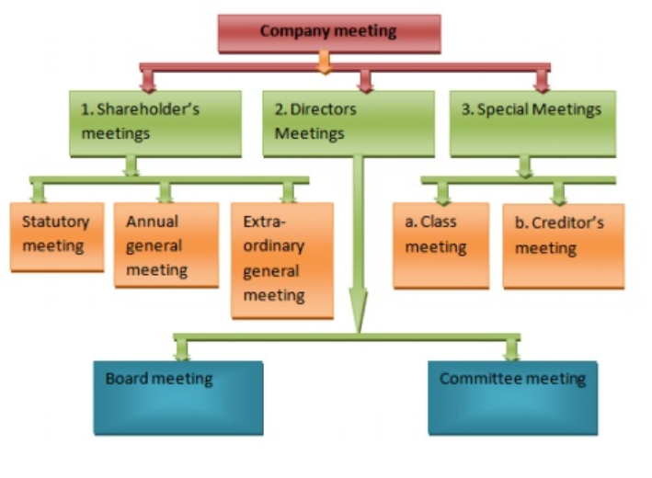

## 1) Shareholders Meetings

The meeting held with the shareholders of the company is called shareholders meeting. The shareholders meeting can be classified as statutory meeting, annual general meeting and extra ordinary general meeting

### a) Statutory Meeting

According to Companies Act, every public company, should hold a meeting of the shareholders within 6 months but not earlier than one month from the date of commencement of business of the company. This is the first general meeting of the public company is called the Statutory Meeting.

This meeting is conducted only once in the lifetime of the company. A private company or a public company having no share capital need not conduct a statutory meeting. The company gives the circular to shareholders before 21 days of the meeting.

### b) Annual General Meeting [AGM]

Every year a meeting­ is held to transact the ordinary business of the company. Such meeting is called Annual General Meeting of the company (AGM). Company is bound to invite the first general meeting within eighteen months from the date of its registration. Then the general meeting will be held once in every year. The differences between two general meetings should not be more than fifteen months. Every Annual General meeting shall be held during business hours, on a day which is not a public  holiday, at the Registered­ Office of the company or at some other place within the town or village where the Registered Office is situated. AGM should be conducted by both private and public Ltd companies.

### c) Extra-Ordinary General Meeting

Both Statutory meeting and annual general meetings are called as ordinary meetings of a company. All other general meetings other than statutory and annual general meetings are called extraordinary general meetings. If any meeting conducted in between two annual general meeting to deal with some urgent or special or extraordinary nature­ of business is called as extra-ordinary general meetings.

## 02. Meeting of the Directors

Since the administration of the company lies in the hands of the board of directors, they should meet frequently for the proper conduct of the business and to decide policy matters of the company.

### a) Board Meetings

Meetings of directors are called Board Meetings. Meetings of the directors provide a platform to discuss the business and take formal decisions. First meeting of directors should be convened within 30 (Thirty) days from the date of incorporation of the company.

### b) Committee Meetings

Every listed company and every other public company having paid up share capital of ₹10 crore is required to have audit committee. This committee should meet at least four times in a year. In case of other companies, the board of directors shall nominate a director to play the role of audit committee which is functioning as a vigil mechanism.

## 03. Special Meeting

### a) Class Meeting (Meetings of Particular Share or Debenture Holders)

Meetings, which are held by a particular class of share or debenture holders e.g. preference shareholders or debenture holders is known as class meeting. The debenture holders of a particular class conduct these meetings. These meetings are held according to the rules and regulations laid by the Trust Deed or Debenture Bond, from time to time, where the interests of the debenture holders play vital role at the time of re-organisation, reconstruction, amalgamation or winding-up of the company.

### b) Meetings of the Creditors

Strictly speaking, these are not meetings of a company. Unlike the meetings of a company, there arise situation in which a company may wish to arrive at a consensuses with the creditors to avoid any crisis or to evolve compromise or to introduce any new proposals.

49. Explain the various meetings by members? In brief.

50. What is AGM? Provisions relating to AGM.

* An annual general meeting (AGM) is the yearly gathering of a company's interested shareholders.
* At an annual general meeting (AGM), directors of the company present the company's financial performance and shareholders vote on the issues at hand.
* Shareholders who do not attend the meeting in person may usually vote by proxy, which can be done online or by mail.
* At an AGM, there is often a time set aside for shareholders to ask questions to the directors of the company.
* Activist shareholders may use an AGM as an opportunity to express their concerns.

## **Relevant Provisions Relating to Annual General Meeting**

1. In the case of the **1STAnnual General Meeting** – The meeting shall be held within 9 months from the date of closing of the 1st financial year of the Company.
2. **Subsequent Annual General Meeting** – Within 6 months from the date of end of the financial year.
3. It shall not be necessary for the company to conduct an annual general meeting in the year of its incorporation if the company holds its annual general meeting as mentioned above.
4. Every Company shall in addition to any other meeting, hold an annual general meeting and shall specify the meeting as such in the notices to be circulated to the members and not more than 15 months shall elapse between the 2 annual general meetings.

51. What is EGM? Under what circumstances is it conducted?

* An Extraordinary General Meeting (EGM) is a meeting held by a company to deliberate upon matters that require the urgent attention of senior executives, the board of directors, and all shareholders and cannot be deferred till the next scheduled annual general meeting.
* According to the Indian Companies Act, 2013, an EGM can be convened by the board as well as by specific members/shareholders of the company that fulfills certain criteria.
* Usually, the EGM is conducted by the chairman who reads out the resolutions, addresses the questions and concerns of the members, oversees the voting, and declares the results.

### MANDATORY REQUIREMENTS

* The Board shall, at the requisition made by
  + in the case of a company having a share capital, such number of members who hold, on the date of the receipt of the requisition, not less than one-tenth of such of the paid-up share capital of the company as on that date carries the right of voting.
  + in the case of a company not having a share capital, such number of members who have, on the date of receipt of the requisition, not less than one-tenth of the total voting power of all the members having on the said date a right to vote, call an extraordinary general meeting of the company.
* If the Board does not, within twenty-one days from the date of receipt of a valid requisition in regard to any matter, proceed to call a meeting for the consideration of that matter on a day not later than forty-five days from the date of receipt of such requisition, the meeting may be called and held by the requisitionists themselves within a period of three months from the date of the requisition.
* Quorum must be present within half-an-hour from the time appointed for holding the meeting otherwise the meeting shall stand cancelled.

52. Explain the various Board meetings of Directors?

53. What are the essentials of a valid meeting?

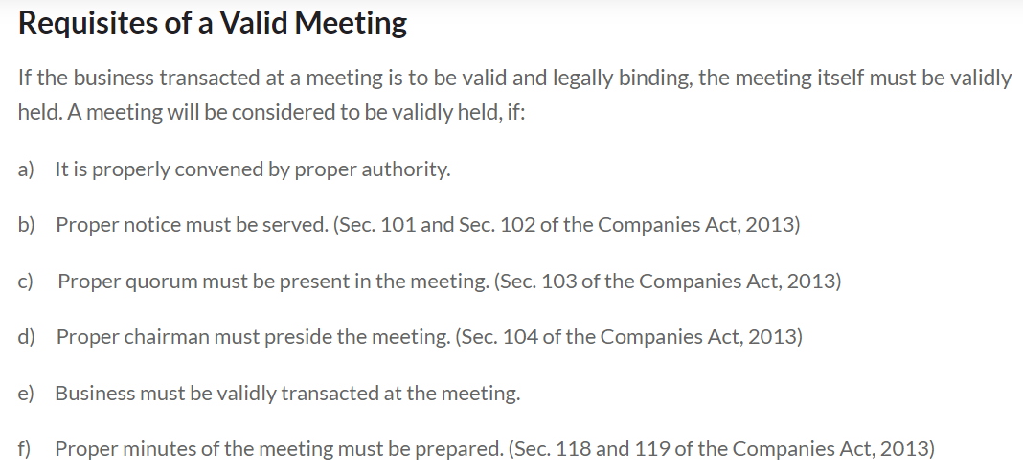

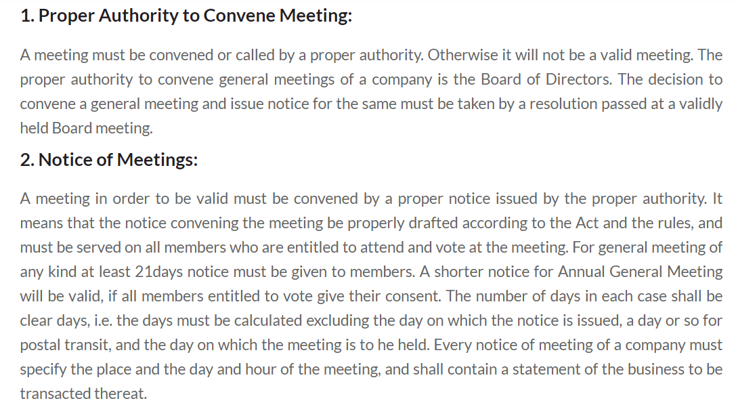

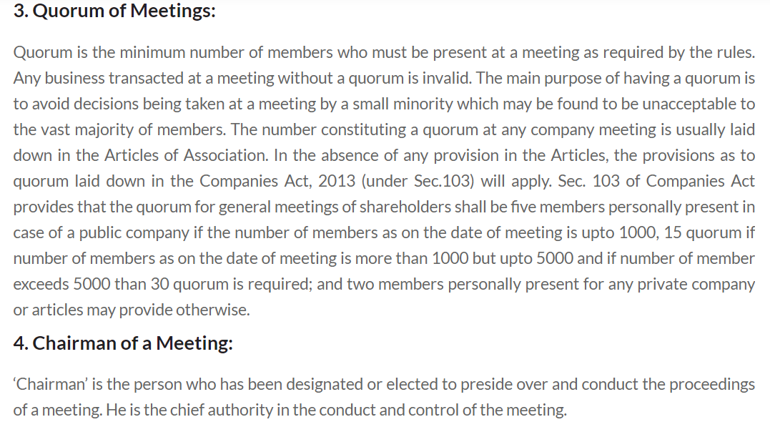

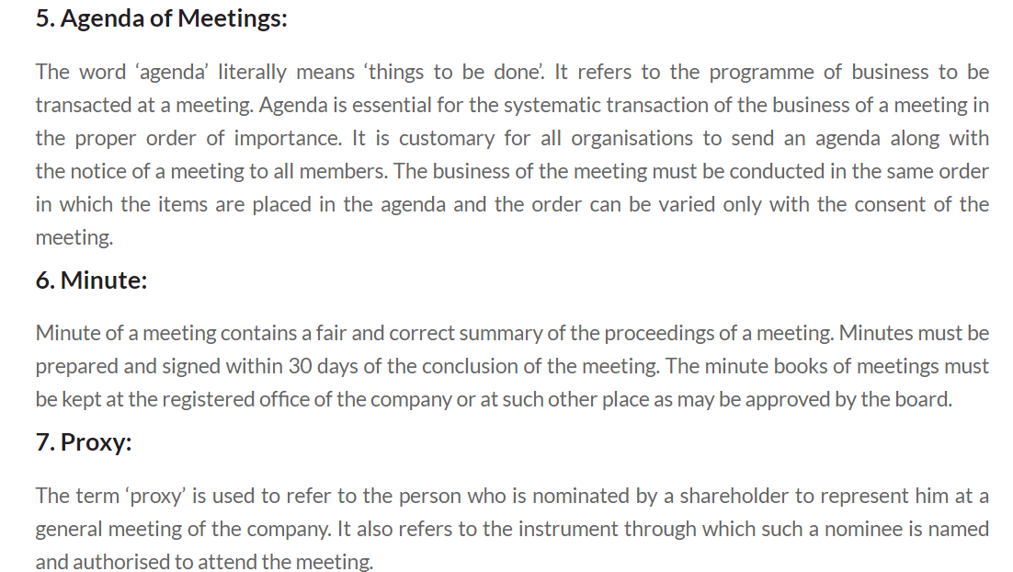

54. What do you mean by winding up of a company? What are the various modes of winding up?

* Winding up refers to the process of liquidating the assets of a business that has ceased operations.
* The sole purpose of a business that is winding up is to sell off assets, pay off creditors, and distribute any remaining assets to the owners.
* The two main types of winding up are compulsory winding up and voluntary winding up.
* Winding up a business is not the same as bankruptcy, although it is usually an end result of bankruptcy.

According to Section 270 of the Companies Act, 2013, a company can be wind up in two ways. They are:

* Compulsory Winding up of Company by Tribunal
* Voluntary Winding up of Company

1) Winding Up by the Tribunal:

A company may, on a petition under section 272, be wound up by the

Tribunal—

1) if the company has, by special resolution, resolved that the company be

wound up by the Tribunal;

2) if the company has acted against the interests of the sovereignty and

Integrity of India, the security of the State, friendly relations with foreign

States, public order, decency or morality;

3) if on an application made by the Registrar or any other person authorised by

the Central Government by notification under this Act, the Tribunal is of the

opinion that the affairs of the company have been conducted in a fraudulent

manner or the company was formed for fraudulent and unlawful purpose or

the persons concerned in the formation or management of its affairs have

been guilty of fraud, misfeasance or misconduct in connection therewith

and that it is proper that the company be wound up;

4) if the company has made a default in filing with the Registrar its financial

statements or annual returns for immediately preceding five consecutive

financial years; or

5) if the Tribunal is of the opinion that it is just and equitable that the company

should be wound up.

Petition for Winding Up to Tribunal can be made by

– The Company

– Any Contributory or Contributories

– All or any of the persons specified above

– The Registrar

– Any person authorized by Central Government in that behalf

2) Voluntary Winding Up:

Chapter V of the Insolvency and Bankruptcy Code of India, 2016, deals with the

Voluntary Liquidation of Corporate Persons. Voluntary liquidation proceedings

can be initiated by a corporate person if it has not committed any default.

a) a declaration from majority of the Directors of the company verified by an

affidavit is required stating that—

* they have made a full inquiry into the affairs of the company and

they have formed an opinion that either the company has no debt or

that it will be able to pay its debts in full from the proceeds of assets

to be sold in the voluntary liquidation; and

* the company is not being liquidated to defraud any person

b) Within four weeks of a declaration at (a) above, there shall be in a general

meeting—

i) a special resolution of the members, to liquidated the company

voluntarily and appointing an insolvency professional to act as the

liquidator; or

ii) a resolution of the members, to be liquidated voluntarily as a result of

expiry of the period of its duration, if any, fixed by its articles or on the

occurrence of any event in respect of which the articles provide that

the company shall be dissolved, as the case may be and appointing an

insolvency professional to act as the liquidator.

c) Provided that the company owes any debt to any person, creditors

representing two thirds in value of the debt of the company shall approve

the resolution passed within seven days of such resolution.

d) The company shall notify the Registrar of Companies and the Board about

the resolution to liquidate the company within seven days of such resolution

or the subsequent approval by the creditors, as the case may be.

e) Subject to approval of the creditors, the voluntary liquidation proceedings

in respect of a company shall be deemed to have commenced from the date

of passing of the resolution